V8 Beef Stew for Two

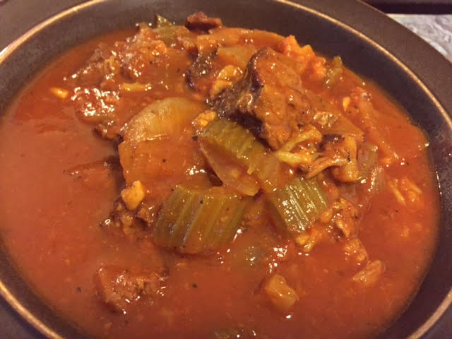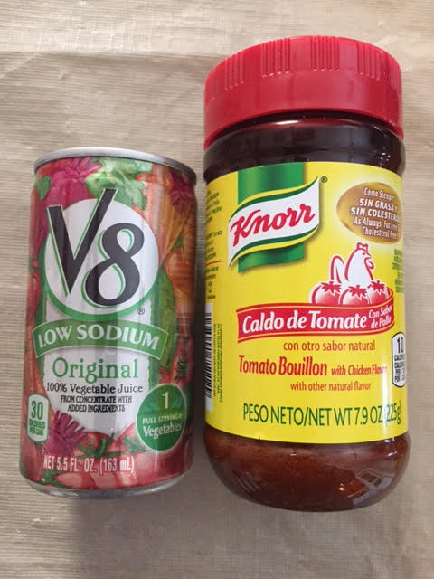

This rich stew is super delicious, easy to make and really low on carbs!

Ingredients:
1 pound beef rump roast (“bottom roound”), cut into 1” – 2” cubes
¼ head cauliflower, washed and chopped into florets
1 medium onion, large chopped
2 ribs celery, chopped
2 – 4 cloves garlic, peeled and minced
1½ teaspoons Worcestershire sauce
25 – 30 ounces V8 vegetable juice
¼ teaspoon paprika
½ teaspoon salt, more to taste
½ teaspoon ground, pepper, more to taste
¼ cup all-purpose flour (low-carb: Tapioca or almond flour)
1 tablespoon Knorr tomato-chicken bouillon, more to taste
2 tablespoons olive oil

Preparation:
Season cubed beef with ¼ teaspoon salt and ¼ teaspoon pepper. Coat the beef in flour - make sure the cubes are well coated, but do not have any clumps of flour.

Brown the floured beef in a skillet with the olive oil, then deglaze the skillet with the vegetables and about 6 ounces of the V8 juice. Season the meat and vegetables with the remaining salt, pepper, bouillon and the paprika, then stir in the Worcestershire sauce before pouring everything into a small slow cooker.

Pour V8 juice over the top of everything, cover and cook on high for 5 hours, stirring halfway through.

