Slow-Cooker Tater Tots and Breakfast-Sausage Casserole (serves 4 – 5)

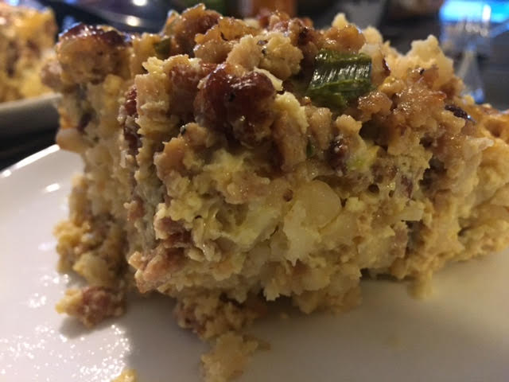

Ingredients:
- ½ pound ground breakfast sausage
- 2 - 4 cups frozen tater tots, enough to cover the bottom of the slow cooker
- 6 large eggs
- ½ cup plus 4 tablespoons milk
- ⅛ - ¼ teaspoon dry mustard (the powdered kind)
- ¾ - 1 cup grated sharp Cheddar cheese
- 1 scallion/green onion, minced (both green and white parts)
- Salt and ground black pepper, to taste

Preparation:
- Preheat a large saucepan on the stovetop over medium-high heat. Crumble in the sausage and cook until crispy and fully cooked through. Drain the sausage on paper towels.

Generously grease the inside of a smaller sized slow-cooker with cooking spray (or use a slow cooker liner). Spread tater tots in the slow cooker, followed by the sausage.

- Whisk together eggs, milk, mustard, salt and pepper in a large bowl. Add cheese and onions. Mix well. Pour egg mixture over sausage and tater tots.

- Cover and cook on low at least 4 hours and up to 5 hours, or until the eggs are fully set. I recommend keeping an eye on the casserole during the last hour or so of cooking—especially if your slow-cooker runs hot—to make sure the edges don't burn. Serve straight from the slow-cooker.

