Pork Chops in Mushroom-Cream Sauce for Two in the Slow Cooker

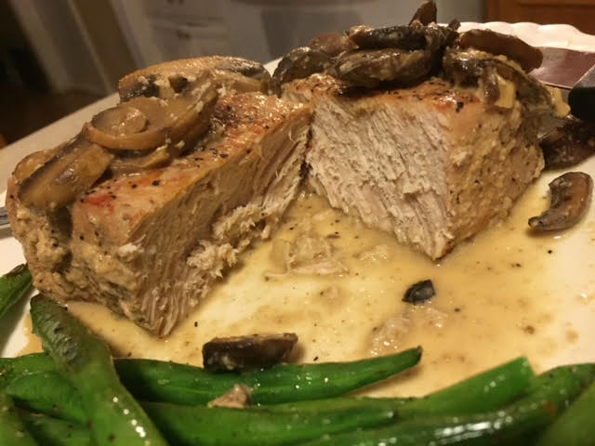

This recipe is reminiscent of German Jäger Schnitzel (jäger is pronounced “yay-ger” – it means “hunter” in German) which is a breaded, fried pork cutlet smothered with a creamy forest-mushroom sauce.

Ingredients:
2 plump pork chops of choice
8 ounces any mushrooms, sliced
1 tablespoon whole-grain mustard
4 cloves garlic, minced
4 tablespoons all-purpose flour
¾ cup water (I use chicken, beef or vegetable stock – whatever’s on hand)
1 tablespoon butter
1 tablespoon vegetable oil
¼ cup cream
Salt and ground black pepper, to taste

Preparation:
Season both sides of your pork chops with salt and pepper. Put a large skillet on high heat and add in the oil. When the oil just starts to smoke, brown the pork chops well on both sides. Place the browned pork chops level in the bottom of a smaller-sized slow-cooker.

In the same pan, melt butter. Add in the mushrooms and garlic, season with a little salt and pepper; sauté until soft. Mix the flour into mushrooms and cook for another 3 – 5 minutes. Be sure you are stirring constantly to prevent the flour from burning.

Deglaze the pan with the water (or stock) and scrape off all the little bits stuck to the bottom of the pan. Allow to simmer several minutes until noticeably reduced and thickened, then thoroughly mix in the mustard and cream.

Carefully pour the mushroom mixture into the slow-cooker over the chops. Cover; cook on low for 4 hours (or high 2 hours). Serve with rice, pasta and/or vegetables.

