Slow Cooker Korean-Style Beef for Two

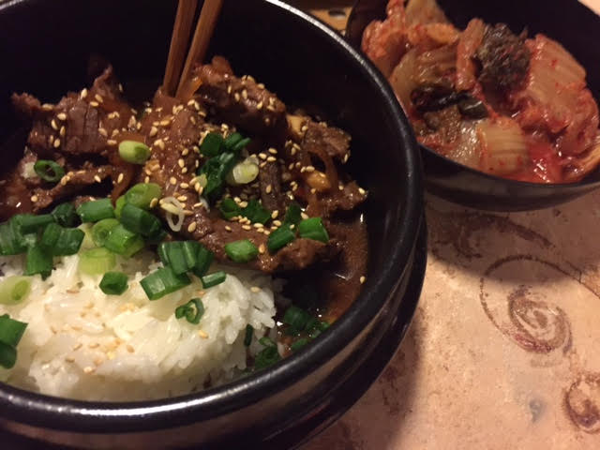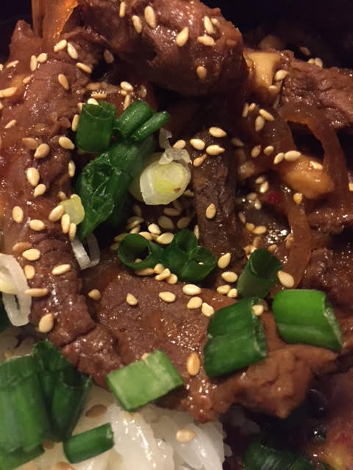

Less than three hours on the low setting, but this exotic beef turns out succulent and tender!

Ingredients:
1 pound beef top sirloin, very thinly sliced into strips (I have the butcher do it)
1 small or ½ a medium-sized onion, thinly sliced
3 garlic cloves, minced
1½ teaspoons ginger, finely minced into a paste
½ teaspoon Korean or other type crushed red-chili flakes
¼ cup soy sauce
¼ cup brown sugar
¼ cup beef broth
1½ teaspoons Korean or other type chili paste
1 tablespoon rice wine vinegar
1½ teaspoons sesame oil
2 green onions, thinly sliced (for garnish)
1 tablespoon cornstarch
1½ teaspoons sesame seeds, to garnish the beef for serving

Preparation:
In a 16-ounce measuring cup, combine onion, garlic, ginger, chili flakes, soy sauce, brown sugar, beef broth, chili paste, vinegar and sesame oil; mix well.

Place the beef strips in a smaller, medium-sized slow cooker. Pour in the contents of the measuring cup and stir thoroughly, making sure each piece of beef is coated with sauce. Cover and cook for 2 hours on low.

Make a slurry by mixing the corn starch with 2 tablespoons of water. Pour into the slow cooker and mix well. Allow to cook for another 45 minutes on low.

Garnish with green onions and sesame seeds, then serve with steamed jasmine rice and, of course, spicy Korean kimchee on the side.

