Gyros for Two

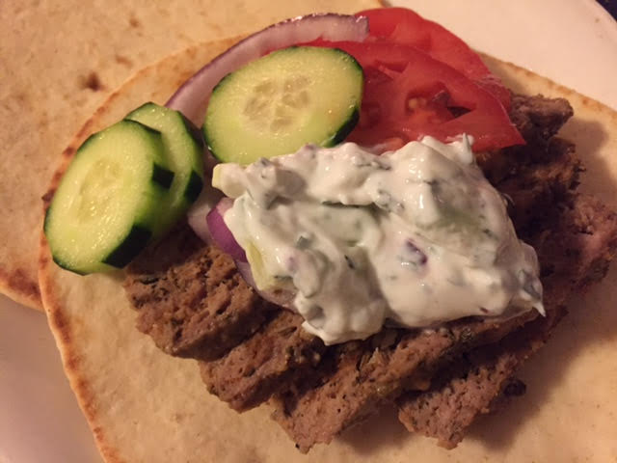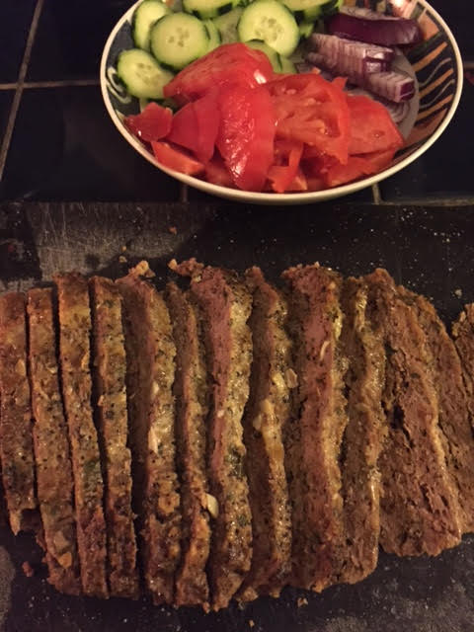

Ingredients:
½ pound ground chuck steak
½ pound ground lamb
½ a large egg
4 tablespoons breadcrumbs
2 cloves garlic, minced
4 tablespoons fresh parsley, chopped
½ teaspoon salt
1½ teaspoons oregano
½ teaspoon rosemary
½ teaspoon thyme
½ teaspoon ground, black pepper
1 teaspoon paprika
¼ teaspoon cumin
juice of ¼ - ½ lemon

Preparation:
In a small bowl, combine garlic, salt, oregano, rosemary, thyme, pepper, paprika and cumin.

Place the ground meats into a bowl and add the herb mixture, breadcrumbs, parsley and egg. Mix thoroughly with clean hands and form a large meatball.

Flatten the ball into a thick disc after you place it in a 2-quart slow cooker, then squeeze over the lemon juice with a little more salt and pepper; set to cook for 3- 4 hours on low.

Serve by slicing the meat carefully and piling it into warm pita bread with Greek-style yogurt, tzatziki sauce, tomatoes, lettuce, red onions and cucumber.

