Cinnamon Apple Cobbler in a Slow Cooker

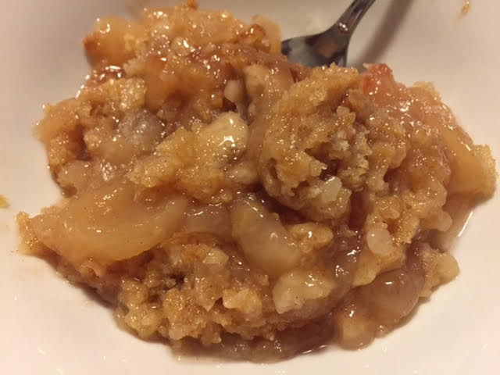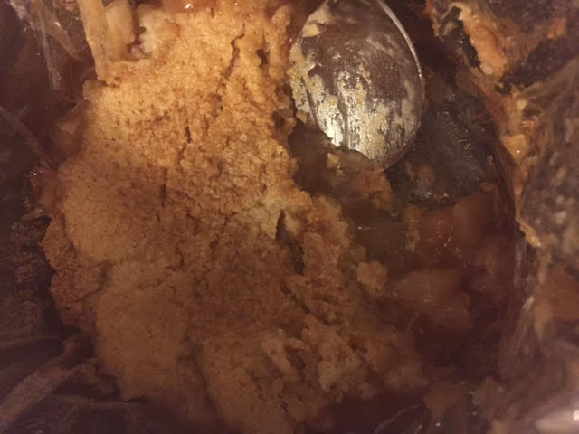

I cut this recipe in half and I use a medium-sized slow cooker for just the two of us.

Ingredients:
2, 20-ounce cans of apple pie filling
1 pack white cake mix
½ teaspoon cinnamon
6 tablespoons unsalted butter, cubed
1 teaspoon cinnamon sugar (see note below)

Preparation:
Into a medium sized bowl, mix cake mix and cinnamon. Add in butter and mix until crumbly.

Into a 6-quart slow cooker, spread the apple pie filling. Sprinkle cinnamon sugar over the top of the apples. Then evenly distribute the cake mix on top. No need to get out all the crumbly bits (in fact, it’s best that you don’t for this recipe!).

Cover and cook on high for 2 hours.

Note:
To make cinnamon sugar, just mix thoroughly together 8 parts regular, granulated white sugar with 1 part cinnamon. For this recipe, I mix 1 teaspoon sugar with ⅛ teaspoon cinnamon.

