Carne Asada in the Slow-Cooker for Two

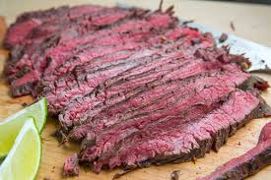

Ingredients:
1 pound skirt steak
1 lime, zested and juiced
1 teaspoon cumin
½ teaspoon paprika
4 cloves garlic, minced
1 teaspoon Mexican oregano, dried
¾ teaspoons salt
¼ teaspoon pepper

Preparation:
Cut skirt steak in half or in thirds so it can fit into slow cooker. Season with salt and pepper. Set aside.

In a small bowl, mix together limejuice, lime zest, cumin, paprika, garlic, and oregano. Rub into the skirt steak.

Place skirt steak into a small slow-cooker and cook on low for 4 hours.

Remove pot from base and partially open lid. Allow to rest for 10 minutes. Slice and serve with chimichurri sauce (Argentinian steak marinade).

