Swedish Prawn Salad Open-face Sandwich (Räksmörgås)

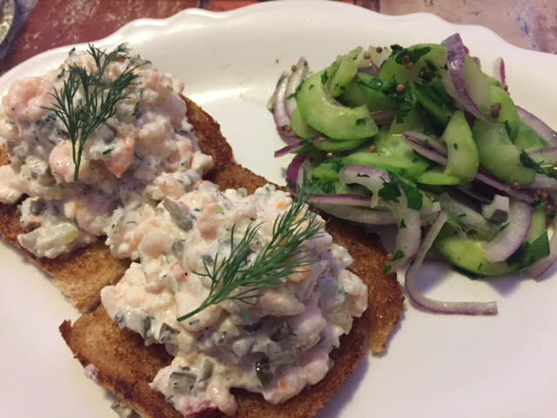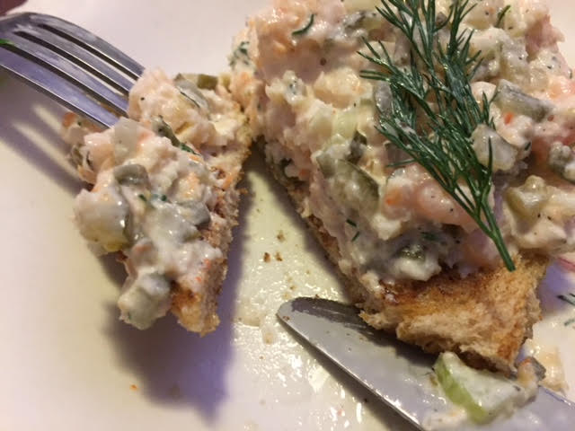

These are quite a treat. Open-face sandwiches are popular all over Scandinavia and are piled high with not only seafood (they call shrimp prawns in Europe), but various meats, as well. If you go to any Scandinavian country and order one of these, eat it with a knife and fork. If you eat it with your hands, you’ll be seen as an ape!

Ingredients per Serving:
1 4-ounce can of tiny shrimp
¼ teaspoon salt
¼ teaspoon lemon pepper
1 tablespoon chopped, fresh dill, plus a couple of sprigs for garnishing
1 tablespoon finely minced celery and/or shallots and/or chives
3 tablespoons pickle relish or finely chopped sweet pickle
3 tablespoons mayonnaise
2 slices of whole wheat bread, crusts removed
4 tablespoons butter

Preparation:
Place the shrimp in a medium sized mixing bowl. Chop celery/shallots and pickles. Add celery/onion, pickle, salt, lemon pepper, dill and mayonnaise. Toss with large spoon to mix well.

Melt the butter in a skillet over medium heat until it starts sizzling. Brown the slices of bread on both sides in the butter.

Plate the fried bread slices and spoon half the shrimp salad over each. Garnish with a sprig of dill before serving.
