Tahini Sauce (recipe makes about 1½ cups)

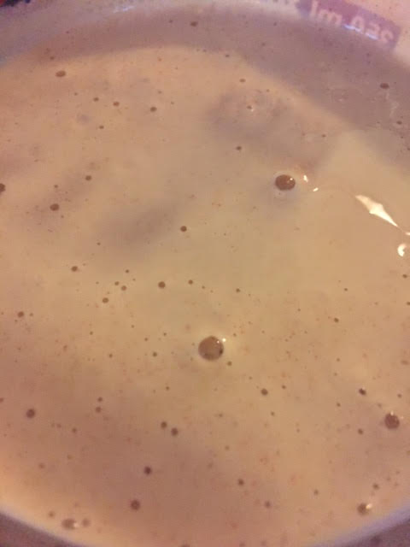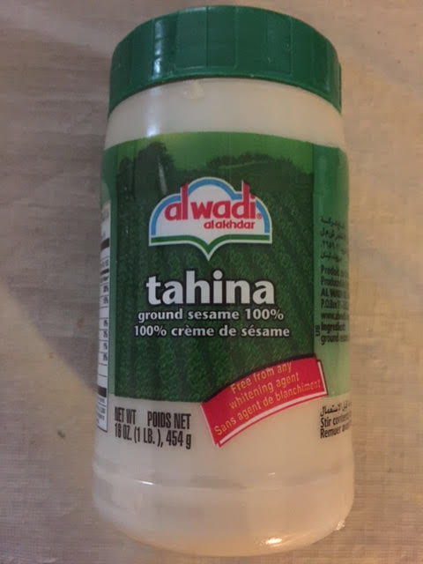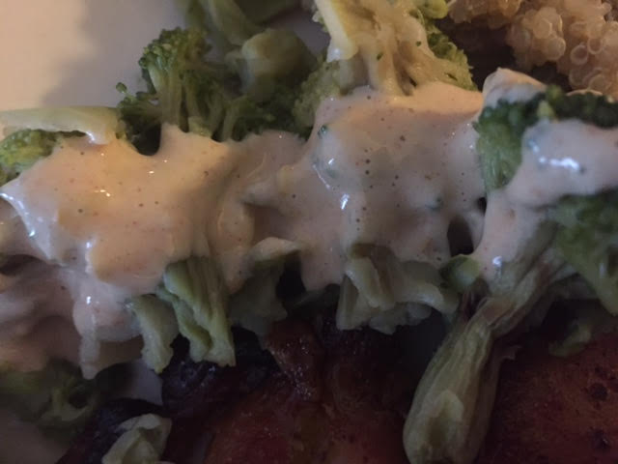

This nutty, zesty, garlicky sauce is also called “taratour” sauce in some parts of the Mideast. It’s great for dipping falafels, pita or other kinds of flat bread and veggie snacks in. It also is a very nice dressing for salad or steamed vegetables.

Ingredients:
½ cup tahina sesame-seed paste
Zest and juice of 1 big lemon
¾ cup water
1 clove garlic, roughly chopped for the food processor
½ teaspoon ground cumin
½ teaspoon paprika
¼ teaspoon salt

Preparation:
Combine all the ingredients in a food processor and pulse until smooth.

