Spicy Mid-Eastern Chickpeas & Potatoes (recipe serves two – makes a great side-dish!).

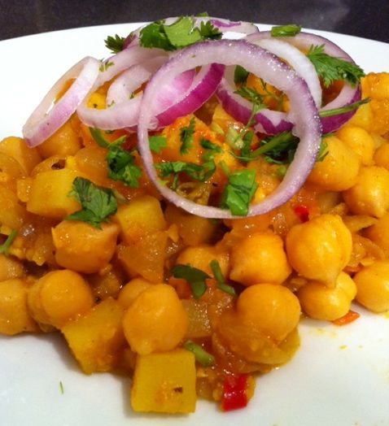

INGREDIENTS:

1, 15-oz. can chickpeas, drained & rinsed
6 tablespoons water
1 small onion, or ½ of a regular onion (about 4 oz.), minced
3 cloves garlic, minced
1 to 2 Serrano and/or red chilies (as hot as you like), minced
¾ teaspoon ground cumin
¼ teaspoon ground turmeric
1 medium-small tomato, diced
½ lb. Yukon Gold potatoes, diced the same size as the chickpeas
salt & ground, black pepper for seasoning as you go (the best way to season!)
ground cayenne to taste
2 tablespoons lemon juice
olive oil, for frying vegetables
Optional Garnishes: 1 very small cucumber, very thinly sliced
1 very small red onion, thinly sliced and separated into rings
1 tablespoon cilantro, finely chopped

PREPARATION:

Place 6 tablespoons of the chickpeas into a food processor with 3 tablespoons water. Season with salt and pepper, puree until smooth. Set aside.

Heat enough olive oil in a small saucepan to fry the onions, garlic and chilies over medium-high heat until the onions are golden brown (be sure to season them with a little salt and pepper, too). Mix in well the cumin, turmeric and cayenne. Stir in the tomatoes, lemon juice and reserved chickpea puree; bring to a boil. Stir in the potatoes, season with a bit more salt and pepper, reduce heat and simmer gently, covered, 15 minutes.

Stir in the remaining chickpeas. Season them and simmer, covered, until thoroughly warmed through and the potatoes are tender, another 10 minutes or so.

Serve garnished with the cucumber, red-onion slices and chopped cilantro, if you like.

