Jeff’s Totally Made-Up Shish Kabob Meat Marinade (makes enough to marinate ½ pound meat or fish).

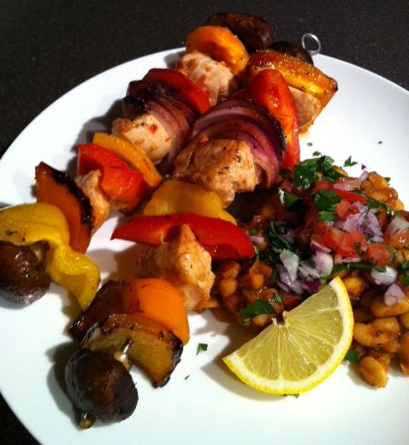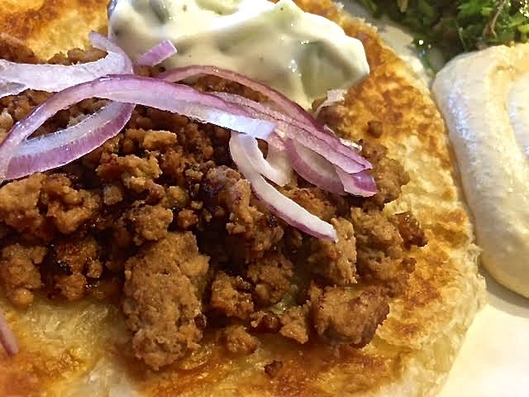

Yeah, I totally made this up. BUT IT WORKS!

Ingredients:
6 tablespoons dry sherry
¼ cup orange juice
1½ teaspoons brown sugar
2 large cloves fresh garlic, crushed and minced
1½ teaspoons hot sauce (I use Asian garlic-chili paste!)
1½ teaspoons soy sauce
1½ teaspoons Worcestershire sauce
2 tablespoons olive oil

Preparation:
Mix together all the ingredients and pour over ½ pound raw protein, like chicken, steak or tuna cut into 1” cubes. This also works great with ground meat, like lamb. Place in a Ziploc baggy, seal the bag with as much air out of it as you can get, message it into the meat a little with your fingers and let it sit at least 2 hours, if not overnight in the fridge.

When ready to cook, shake off the excess marinade and skewer the meat with vegetables of choice (these make enough protein for four skewers – 2 per person). Grill over medium heat, or broil in the oven, until nicely charred. Serve shish kabobs with pita bread and rice or Mideast beans and a nice green salad on the side.

If marinating ground meat, drain the marinade off it as best as you can and fry it in a little olive oil in a skillet or saucepan. Serve the fried meat wrapped in flatbread dressed with thinly sliced red onion and dressed with tahini sauce, cucumber-yogurt salad and/or hummus (or whatever you like).

