Mediterranean Salad (Recipe makes 2 Servings)

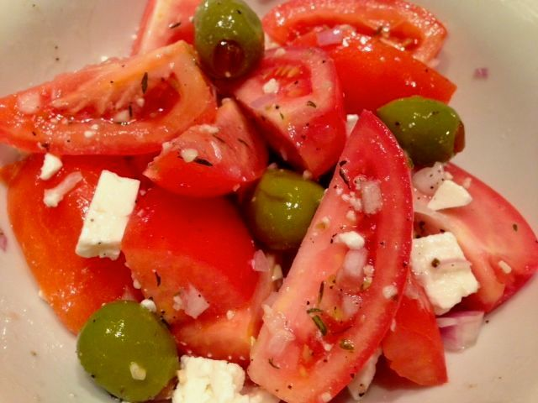

Ingredients:
1 very small, sweet red onion or large shallot (1 ounce), minced
3 Roma tomatoes, quartered
¼ cup (2 ounces) pimento-stuffed olives, whole
3 tablespoons good olive oil
4½ teaspoons lemon juice (the juice of ½ a lemon)
1 very small clove garlic, minced
⅛ teaspoon dried thyme
⅛ teaspoon ground, black pepper
⅛teaspoon dried oregano
¼ cup feta or Parmesan cheese, crumbled

Preparation:
Toss the first three ingredients together in a mixing bowl. Whisk the oil, lemon juice, garlic and herbs together for the dressing. Toss the dressing and the cheese crumbles with the vegetables right before serving.

