Lebanese White Beans – serves two.

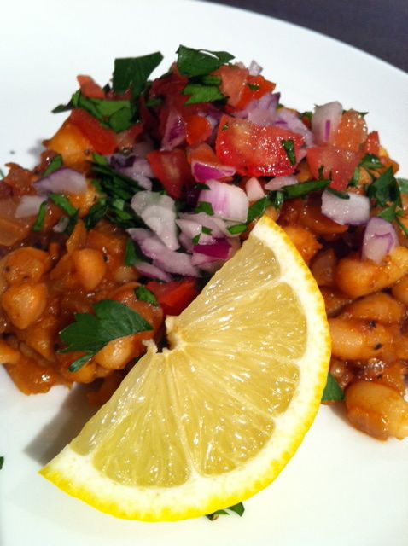

INGREDIENTS:

1, 15-oz. can Great Northern or other white beans, drained and rinsed
½ large or one small white onion (about 4 oz.), finely chopped
1½ teaspoons tomato paste
1 tablespoon lemon juice
3 tablespoons water
3/8 teaspoon ground coriander
¼ teaspoon ground cumin
½ teaspoon each salt & ground, black pepper
1 teaspoon ground cayenne pepper
2 tablespoons olive oil, to fry the onion in
1/8 teaspoon sugar
lemon wedges, chopped parsley, red onion, cucumber and/or tomato for garnishing (optional)

PREPARATION:

Heat the oil in a small saucepan over medium-high heat and add in the chopped onion. Sprinkle the onion with the sugar and just a touch of the salt in order to make it brown darkly quickly.

After the onion caramelizes, add in the rest of the ingredients. Bring the mixture to a gentle simmer for about 10 minutes, until everything is nice and heated through.

Serve as a side dish, garnished with your choice of lemon wedges, chopped parsley, cucumber, red onion and/or tomato.

