Lamb Kafta Skewers (recipe makes enough for 2).

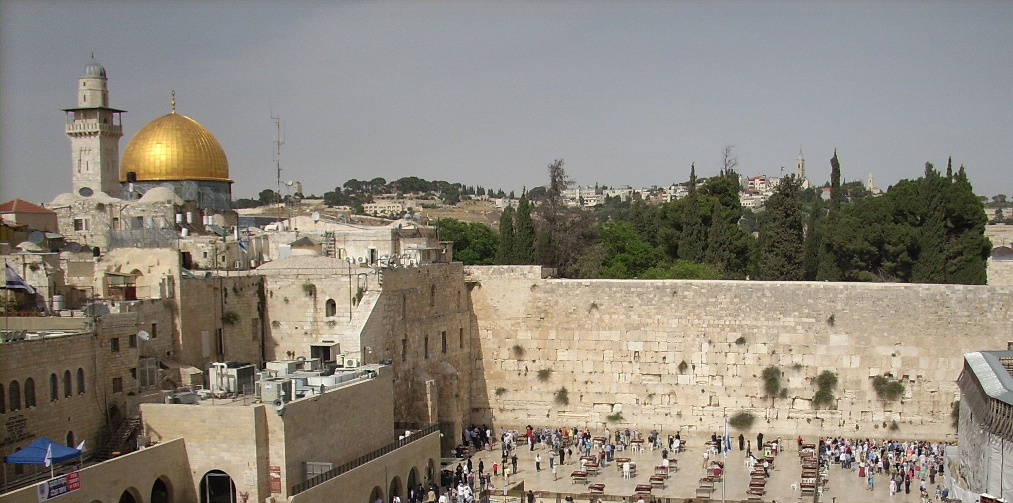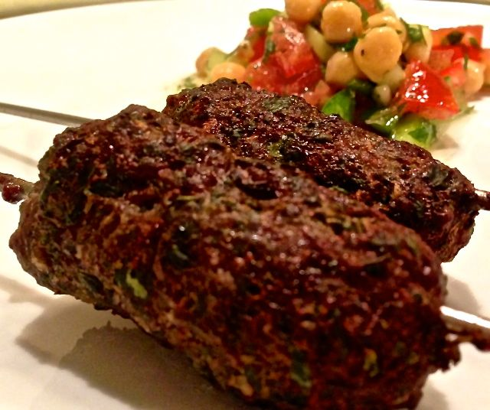

Popular in Israel, this mixture is great on skewers or as patties, grilled over charcoal or under the oven broiler.

Ingredients:
½ pound finely ground lamb or beef
½ cup tightly packed washed and picked parsley
3 tablespoons fresh mint leaves or ½ teaspoon dry mint leaves
1 small onion or large shallot, cut up for food processor
⅛ teaspoon each ground cinnamon, cloves and nutmeg, combined
¼ teaspoon salt, more to taste
¼ teaspoon ground, black pepper, or to taste

You’ll need four skewers.

Preparation:
In a food processor, chop onion extremely fine. Add parsley and mint and pulse until you have a homogeneous mixture.
Put the meat in a large mixing bowl, add all ingredients and spices to meat, combine and mix thoroughly with your hands (I wear latex gloves). Place bowl in fridge for 15 - 30 minutes covered with plastic wrap (helps flavors of the mixture blend).
FOR SKEWERS: Soak wooden skewers (usually found at your local supermarket) in water for a couple of hours or more. Divide the mixture into 4, even balls and shape them into long ovals; work them onto the skewers for ease of handling while cooking (they’re not really necessary, I’ve found). Grill over medium charcoal fire or broil in oven until nicely browned. I set a greased, wire wrack on a foil-lined baking sheet and put it under the broiler with them.

Serve with flat bread and classic Israeli salad!

