Jeff’s Hanukkah Eggs

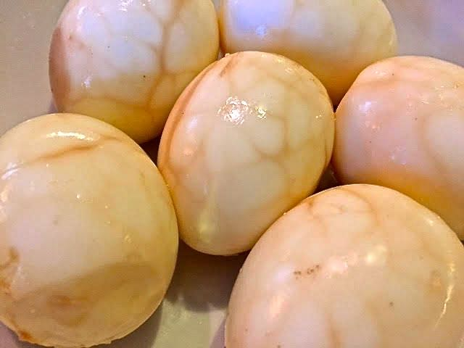

This is a take on the classic Chinese tea-eggs recipe that I like making to serve with green salad before my Hanikkah brisket every year for the 1st night of Hanukkah. (No, I’m not Jewish – but Jesus was!)
Ingredients:
8 large eggs – cold from the fridge
3 cups beef broth and/or bouillon
3 teaspoons BV beef sauce or beefy steak sauce
2 teaspoons Worchestershire sauce
1½ teaspoons salt
½ teaspoon ground, black pepper

Preparation:
Mix the broth/bouillon, BV/steak sauce, Worcestershire, salt and pepper together well in a 2-quart saucepan. Bring it to a boil over medium–high heat. Gently place in your cold eggs (I use a slotted spoon). Cover the saucepan and let them cook 7 minutes, swirling the pan occasionally to insure the egg yolks cook evenly in the shells, then immediately remove the eggs (reserve the broth mixture in the pot) to a large bowl at your kitchen sink; run cold water over the eggs for 30 seconds.

Remove the eggs from the water and gently crack their shells all over, but do not peel them. Return the eggs to the broth mixture in the pot, bring to a high, rolling boil and let cook, stirring, 7 minutes. Cut the heat and fill with ice to the top. Let cool in the ice and broth mixture before peeling.

These make wonderful deviled eggs!

