Israeli Schnitzel for two

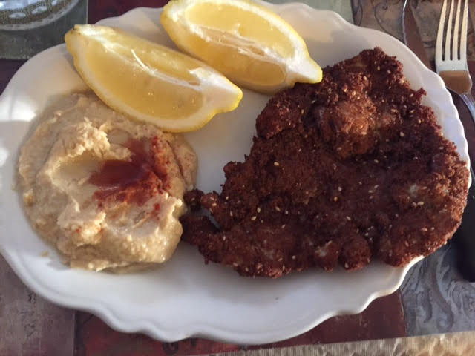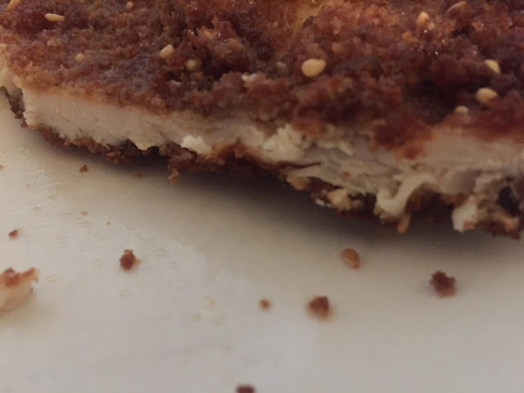

This dish is popular all over Europe in one form or another, and Jews from all over Europe have immigrated to Israel over the years. Jewish friends with close ties to Israel tell me that every Jewish mother in Israel serves her children these Schnitzels.

Ingredients:
2 boneless, skinless chicken breasts
½ cup flour
1 egg, beaten
1 cup breadcrumbs
¼ teaspoon paprika
1 teaspoon toasted sesame seeds
½ teaspoon granulated garlic powder
⅛ teaspoon cayenne pepper or chili powder
Salt and ground, black pepper
Vegetable oil (for frying the Schnitzel)
1 large or 2 small lemons, sliced into wedges

Pound the chicken breasts down to ¼“ thickness (or even less, if you can manage). I sprinkle a little water in a gallon Ziploc bag and pound the chicken in it using a rolling pin. Season the cutlets lightly with a sprinkle of salt and pepper.

Thoroughly combine the breadcrumbs, paprika, sesame seeds, garlic powder, cayenne or chili powder with ½ teaspoon salt and ¼ teaspoon black pepper. On a plate, spread out the flour and season it with a little salt and pepper. Put the beaten egg on a second plate and spread out the breadcrumb mixture on a third plate. Dredge the chicken cutlets first in the flour, then in the egg and then finally in the breadcrumbs.

Pour enough oil to submerge the breaded cutlets in a large pot and heat it to 350° F. Fry both sides of the cutlets until golden brown and reach an internal temperature of 180° F. Using a meat thermometer, I’ve found that the cutlets usually brown almost too much before reaching 180° F., so I just pop them in the microwave on high for 2 minutes after they’re golden. That does the trick! Serve with hummus and Israeli salad. Squeeze lemon wedges over the Schnitzel before eating.

