Israeli Salad – recipe serves about 2.

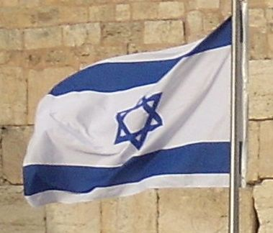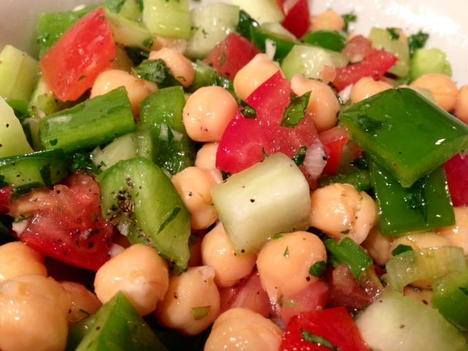

When one orders a “salad” in Israeli restaurants and diners, one will most likely get the following, or some variation.

Ingredients:
2 small tomatoes, diced
1 cucumber, peeled and diced
1 small, green bell pepper, diced
1 green onion/scallion, finely diced
½ of a 19-ounce can chick peas/garbanzos
1 clove fresh garlic, chopped/minced
2 teaspoons fresh parsley, chopped
5 teaspoons fresh mint, chopped
½ cup olive oil (I prefer to use regular, rather than extra-virgin for this)
5 teaspoons fresh lemon juice
Salt and ground black pepper, to taste

Preparation:
Toss all the vegetables in a large bowl. Add the remaining ingredients and mix well. The juice from the tomatoes will eventually leach out and mingle with the olive oil, making for a very nice dressing on its own! Refrigerate until ready to serve. Be sure to give it another good stir before serving.

