Hummus (recipe makes 6 – 8 servings)

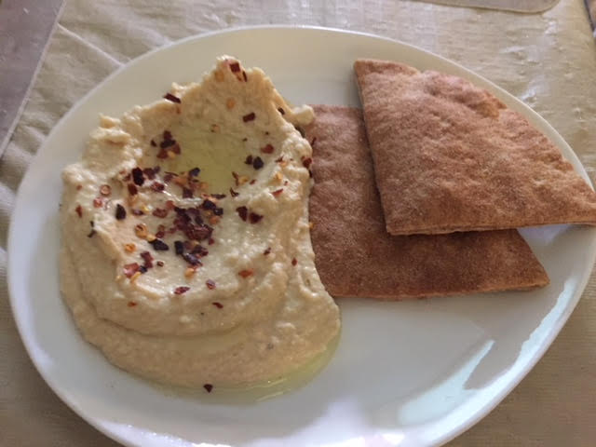

Ingredients:
1 – 2 cloves fresh garlic, peeled
¼ cup lemon juice
2, 15-ounce cans chickpeas/garbanzos, drained and rinsed
½ cup tahini sauce
1 teaspoon salt
½ teaspoon ground, black pepper
¼ - ½ cup olive oil
½ - 1 cup water

Preparation:
Combine the garlic with the lemon juice in the food processor. Process until well combined and allow to sit for about 10 minutes so that the lemon juice can mellow out the garlic. Add the chickpeas with the tahini sauce, salt and pepper; process while drizzling in olive oil so that it is a good consistency. Add in ½ to 1 cup of water until the chickpeas cooperate and become smooth.

Serve drizzled with more olive oil and a sprinkling of crushed red-pepper flakes (optional), along side pita corners.

