Hanukkah Beef Brisket – recipe serves 4 – 6.

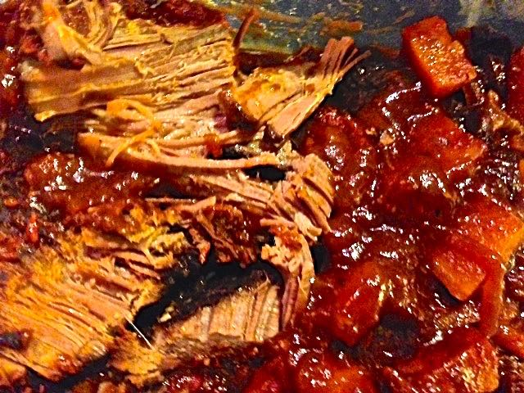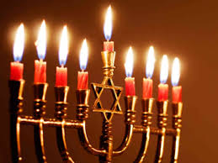

Although I’m not Jewish, I like making this every year for the 1st night of Hanukkah.
Ingredients:
1 large onion, thinly sliced
2½ pounds well-trimmed beef brisket
½ teaspoon salt
½ teaspoon black pepper
12-ounce bottle chili sauce, divided in half (generic brand actually works best)
4½ teaspoons brown sugar
¼ teaspoon cinnamon
2 sweet potatoes, peeled, cut into 1” pieces
7 – 8 ounces pitted dried plums (prunes – about 1 cup’s worth in volume)
2 tablespoons cornstarch
2 tablespoons cold water

Preparation:
Place onion in medium-sized slow cooker. Sprinkle with a little salt and pepper. Place brisket over onions (tucking edges under to fit, if necessary). Sprinkle salt and pepper over brisket. Spoon half the chili sauce over brisket. Cover and cook on “High” for 3½ hours (or “Low” for 6 hours).
Mix remaining chili sauce, brown sugar and cinnamon together in large mixing bowl with a sprinkle of salt. Add sweet potatoes and prunes; toss to coat. Spoon mixture over brisket. Cover and cook on “High” for 1¼ to 1½ hours (“Low” for 2½ - 3 hours), or until brisket and sweet potatoes are tender.
Transfer brisket to carving board; tent with foil. Transfer vegetables to serving dish, leaving juices in slow cooker. Keep vegetables warm.
Mix cornstarch with water until smooth. Stir mixture into slow cooker juices. Cover and cook on “High” for 10 minutes, or until sauce thickens.
Carve brisket across the grain into thin slices. Arrange on serving platter with vegetables. Top with juices. Serve “family” style.

