Egyptian “Chili” (Foule/ Ful) for Two

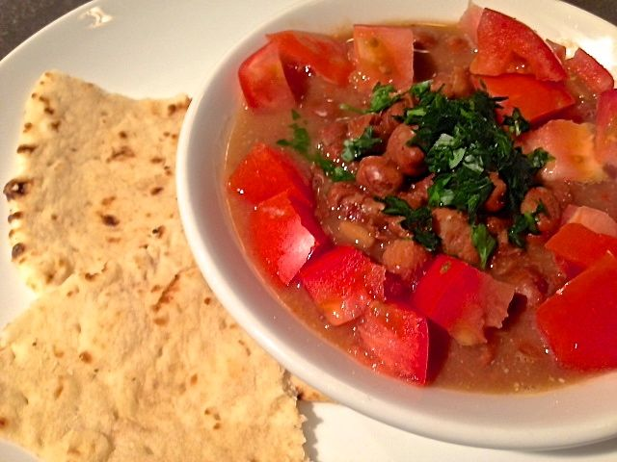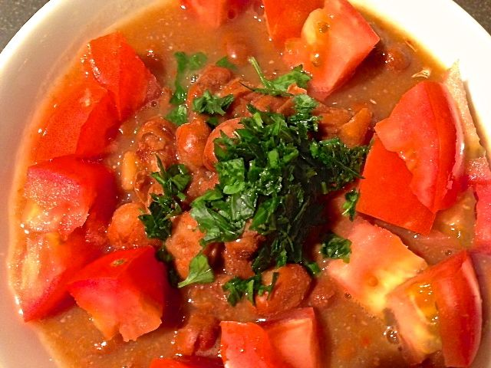

This is eaten for breakfast in Egypt. But I love it any time of the day loaded with tons of crushed, red-pepper flakes.

Ingredients:
2, 15½-ounce cans fava beans (ful medammes), drained and rinsed
½ cup water, vegetable or chicken broth
2 cloves garlic, pressed and minced
½ teaspoon cumin
2 tablespoons lemon juice (the juice of 1 lemon)
Salt and crushed, red-pepper flakes, to taste
1 medium-sized tomato, chopped
Olive oil
2 tablespoons fresh parsley, finely chopped

Preparation:
Heat the beans with the water or broth gently in large saucepan until boiling. Simmer on low for 10 minutes to heat through. (Alternatively, heat beans in microwave.)

In a small bowl, mix the garlic with the cumin, lemon juice, and salt.

Mash about ¼ of the beans with a wooden spoon, pestle or potato masher, leaving most beans intact. Add the lemon juice mixture and gently stir in. Taste and add more salt or lemon juice if necessary.

Transfer the foule to shallow serving dishes. Top with the chopped tomato, a generous drizzle of olive oil and the chopped parsley.

Serve warm or at room temperature with sweet tea and Mid-Eastern flat bread. Optional additions on the side: Extra lemon wedges, chopped onion, sliced cucumber, chopped green pepper, fresh mint, crumbled feta cheese and/or one hard-cooked egg for each person.

