Extra-Creamy Hummus (recipe makes just over 16 ounces of dip)

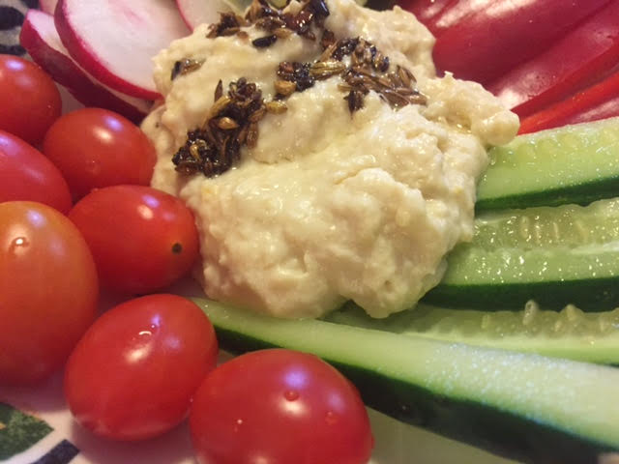

You can make extra-creamy hummus using chickpea flour instead of whole chickpeas. Look for the flour at specialty and health-food stores, or it is also sold at Indian groceries as “gram flour” and/or “besan.”

Ingredients:
1 cup chickpea flour , sifted
½ cup tahini sauce
3 tablespoons olive oil (plus 2 extra tablespoons – to make optional dressing)
2 lemons, zested and juiced
¼ teaspoon cumin seeds (optional)
¼ teaspoon fennel seeds (optional)
Crushed red-pepper flakes, to taste (optional)

Preparation:
Bring 2¾ cups of lightly salted water just to a boil. Whisk in the chickpea flour and cook 2 minutes. Remove from the heat and whisk in the tahini, 3 tablespoons olive oil and the zest and juice of the lemons. The mixture will thicken nicely as it cools.

To make a nice, spice-infused oil to drizzle over the hummus when serving, toast the cumin and fennel seeds in a skillet; add some red-pepper flakes and 2 tablespoons olive oil; sauté 30 seconds. Let cool before dressing the hummus with it.

Personally, I just like it with a little olive oil drizzled on it with some crushed red-pepper flakes and a little extra salt sprinkled on it.

