Chicken Kafta Kababs – recipe makes 2 servings (2 kabab-filled pitas per serving).

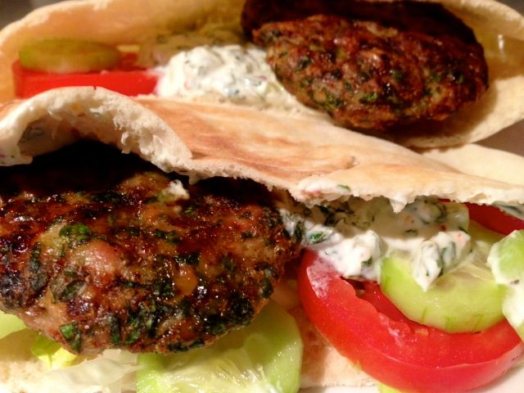

Ingredients:
½ pound ground chicken thighs (dark meat)
3 tablespoons red onion or a large shallot, coarsely chopped
2 – 3 tabelspoons fresh parsley (to taste, basically – I like to use a lot!)
1 teaspoon ground coriander
1 teaspoon cumin
½ teaspoon granulated garlic powder
½ teaspoon olive oil
2¼ teaspoons bread crumbs (used because the grated onion makes the meat rather wet)
¼ teaspoon salt
Ground, black pepper, to taste, crushed, red-pepper flakes, to taste
2 normal-sized pitas (whole recipe requires 4 pita-pocket halves, 2 per serving)

Preparation:
Preheat your oven broiler.

In a food processor, chop onion extremely fine. Add parsley and pulse until you have a fine - not liquefied - homogeneous mixture.
Mix all ingredients together in a suitably-sized bowl. Divide mixture in half, then divide each half again, until you have 4, equal portions, and shape into long ovals or patties; for making pita sandwiches, I like to make them into flat, oval patties about ¼“ thick – that way, they’re quite easy to fill regular-sized pita pockets generously with the meat.

Lightly grease an oven-safe grill-pan or a wire rack set on a foil-lined baking sheet, then arrange the patties on top. Put under the broiler and cook for about 5 - 6 minutes each side, until you see nice, black charring going on.

Serve with chopped lettuce, diced cucumber and tomatoes in pita or other flat bread topped with a simple dressing of finely-chopped cucumber and lots of mint mixed with a touch of salt and white, ground pepper in plain yogurt. For two servings (4 pita sandwiches total), I use one, 6-oz. container of plain, Greek-style yogurt, half a small cucumber, the leaves of a whole ¾-oz. pack of mint (those flat, plastic packs they sell in the markets), and ½ teaspoon each of salt and pepper.

