Arabian Celery & Herb Salad

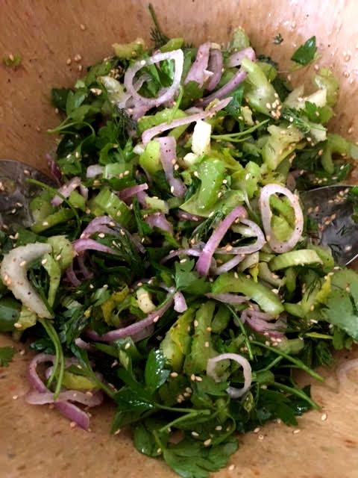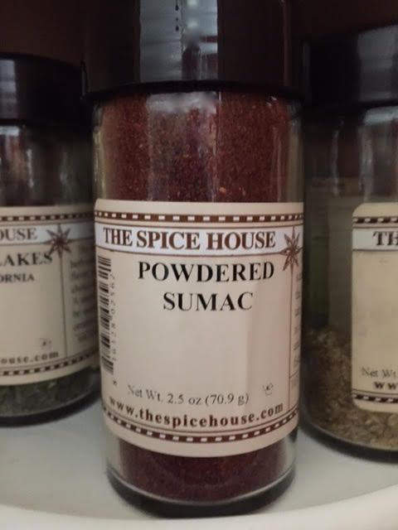

Arabs and Europeans have been trading with one another for centuries, so the addition of fresh, Nordic dill to this salad recipe shouldn’t come as a surprise.

Ingredients:
Juice of one, big lime (3 – 4 tablespoons limejuice)
1 teaspoon sumac (see notes, below)
2 tablespoons toasted sesame seeds
Salt and ground black pepper, to taste
½ cup olive oil
6 ribs celery with leaves, thinly sliced on bias
1 large or 2 small shallots, thinly sliced
1 bunch whole, flat-leaf parsley leaves
¾ ounce fresh dill (one of those little plastic packets from the market)

Preparation:
Whisk together the limejuice, sumac, sesame seeds, salt, pepper and oil. Drizzle it over the celery, shallots, parsley and dill in a large bowl. Toss to combine.

Notes:
Sumac is a red, citrusy Mid-Eastern spice powder sold at any competent spice shop (I get mine from Milwaukee’s Spice House). This salad can be prepared well ahead of serving because the ingredients are not prone to wilting right away after adding the dressing.

