Lenten-Friday Dinner Ideas

Portabella Burgers on the Grill

Vegetarian-Bean Burgers & Crisps

Prawn Salad Sandwiches

Faux Ground Beef and Refried Bean Burritos. Replace the meat in the Beef & Bean Burrito recipe with Morning Farms imitation meat crumbles

Faux Ground Beef Chili. Replace the meat in any favorite chili recipe with Morning Farms imitation meat crumbles

Tuna Stir-Fry over Chowmein Noodles

Tuna Melts

Tuna and Artichoke Paninis

Tuna-Salad-Stuffed Tomatoes and/or Cucumber Boats with Cottage Cheese on the Side

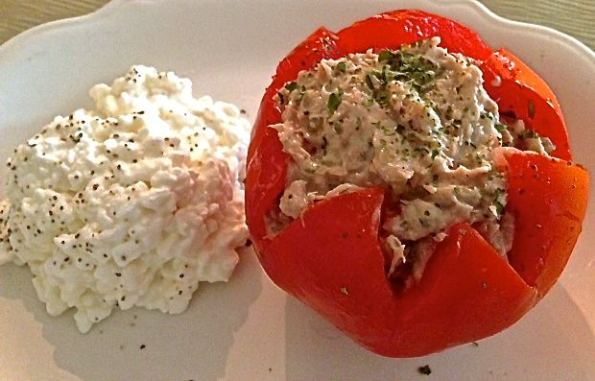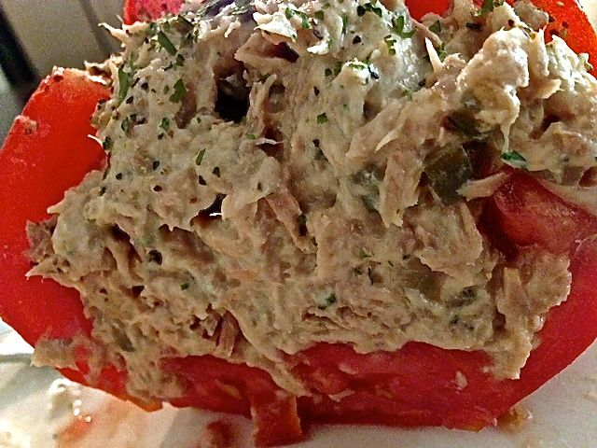

Ingredients Per Serving:
1 large tomato and/or cucumber
5 ounces flaked tuna – the Starkist Herb & Garlic is really nice!
4 - 5 tablespoons Mayonnaise
¼ cup (half a rib) celery, chopped as finely as you can get it
¼ cup scallion (green onion) tops, finely chopped, or 1 - 2 tablespoons dried chives
1 heaping tablespoon sweet pickle relish
¼ teaspoon salt
¼ teaspoon ground, black pepper
¼ teaspoon dried dill weed
Preparation:
Combine all ingredients in a small bowl. Let it chill down in the refrigerator.

Cut the top off the tomato and hollow out with a spoon. Fill with the tuna salad. For cucumbers, peel it, slice in half, use a teaspoon to gut out the seeds and stuff with the tuna salad.

Tuna Salad Sandwiches. See recipe above, but make sandwiches or roll-ups/wraps with it.

Salade Niçoise with Tuna packed in Oil

Spaghetti Aglio e Olio

Penne alla Vodka

Cacio e Pepe

Pasta e Ceci made with Vegetable Broth

Tuna-Stuffed Cherry Peppers

Shrimp Creole

BBQ Shrimp

Shrimp Vindaloo

Prawns on the Barbie

Welsh Rarebit

Fish & Chips

Better-Than-Fast-Food, Fish-Filet Sandwiches

Halibut Curry

Alloo Gobi

Eggs in Purgatory

Swiss Fondue with Meatless Frankfurter, Bread & Vegetables Pieces

Shrimp & Vegetable Tempura

Egg Salad Sandwiches

Gourmet Grilled Cheese Sandwiches

Baked Salmon or Grilled Tuna Dinner with Old-School, Supper-Club Relish Trays and Breadsticks

Spanish Tortilla

Spanish Shrimp Fritters

Assorted Seafood, Vegetable and Fruit Crêpes

Polenta or Pasta with Puttanesca Sauce

Umbrian Baked Fish

Crab Cakes

Tuna Patties

Tuna-Stuffed Piemonte Peppers

Pasta with Various Butter/Crumb Sauces

Egyptian Ful

