Zucchini Parmesan Snack Chips

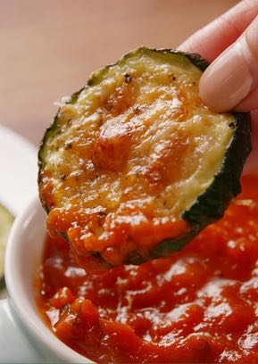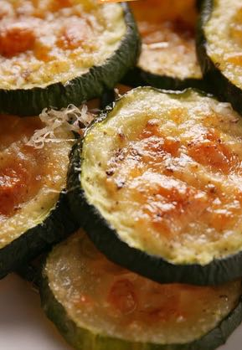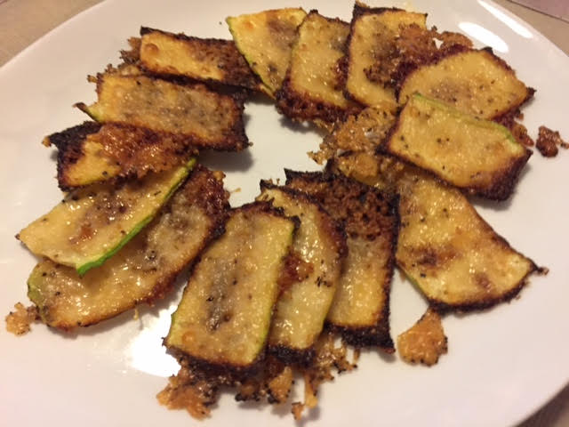

Have you gone low-carb/paleo and are missing those snack chips? These are the perfect answer! I like to make these by shaving the zucchini lengthwise into “planks” and cutting those into regular snack-chip sized pieces (pictured above right). I also sprinkle a little granulated garlic powder on them before baking.

Ingredients:
2 large zucchinis, thinly sliced
Salt and ground, black pepper
1½ cups grated Parmesan cheese
Marinara sauce, for dipping

Preparation:
Preheat oven to 400º and line a baking sheet with parchment.

Arrange zucchini slices on baking sheets and season with salt and pepper. Top each with Parmesan.

Bake until deeply golden and crisp, 20 to 25 minutes. Serve with marinara.

