Spinach & Beans – recipe makes about 4 servings

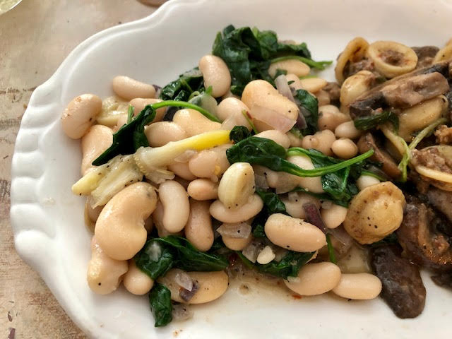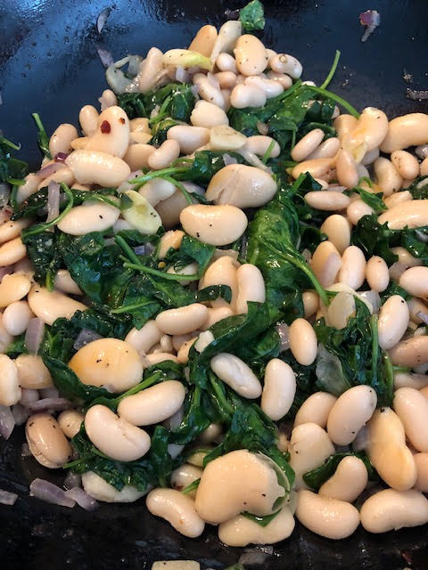

This is another great Italian-American recipe from the area of Pittsburgh, PA. It goes great as a side dish for practically anything.
Ingredients:
3 – 4 cloves garlic, sliced
2 – 3 tablespoons olive oil
5 – 6 ounces baby spinach
½ or 1 small, red onion, diced
1 teaspoon salt
½ teaspoon ground, black pepper
15 ounces butter beans, drained and rinsed
15 ounces cannellini beans, drained and rinsed
½ stick (4 tablespoons) butter

Preparation:
Warm the oil with the garlic – let the garlic infuse the oil for about 5 minutes at medium heat. Add in the spinach and let it wilt with the minced onion. Season with salt and pepper. Add ½ stick butter. Add the beans, cover the pot and cook over medium-low heat 15 minutes.

