Spicy Italian “Drip Beef” for Two

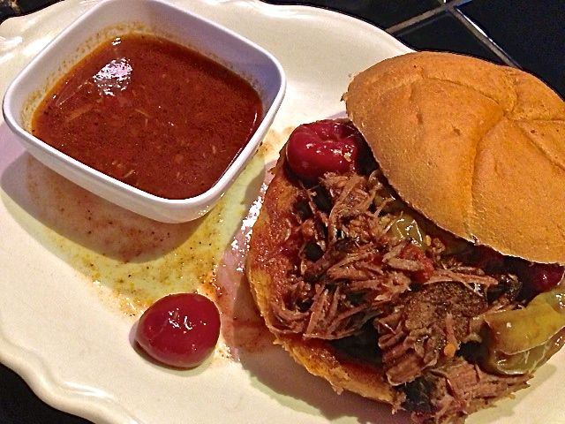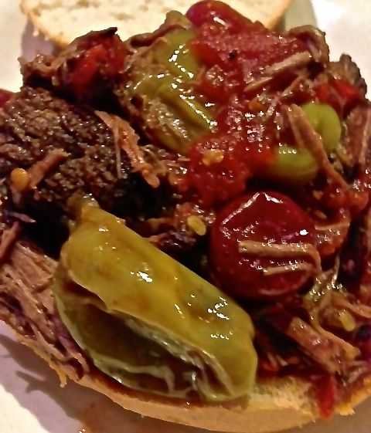

Ingredients:
1½ teaspoons olive oil
¾ pound (12 ounces) Chuck Roast
Salt and ground, black pepper
8 ounces beef broth
7 ounces canned, whole tomatoes, crushed by hand
4 ounces hot yellow peppers (“pepperoncini”), with ½ cup of their juice
4 ounces hot cherry peppers, drained
1 ounce jarred pimentos
Buttered po-boy/sub-sandwich bread (optional)

Preparation:
Preheat oven to 300° F.

Heat the olive oil in a heavy, large pot over high heat. Salt and pepper the chuck roast on both sides, then sear it until deep golden brown on both sides, about 1½ minutes per side. Remove roast from pot and set aside on a plate.

Reduce heat to medium. Pour in beef broth, whisking to scrape the bottom of the pot. Pour in crushed tomatoes, pepperoncinis and juice, and the drained hot cherry peppers. Stir to combine, then add the roast back to the pot.

Place the lid on the pot and place the pot in the oven. Cook for 4 hours, or until meat is fork tender. If it's not, return the pot to the oven for another 30 to 45 minutes, or until it's falling apart. Or cook it in a slow-cooker on high heat 12 hours (you can prepare it the night before and start it before going to bed on low heat for next day’s supper).

Skim off any fat from the top. Remove the roast to a cutting board and use two forks to shred it into big chunks, then return the meat to the cooking liquid. Serve on the toasted bread.

