Pull-Apart Pizza Monkey Bread (recipe serves 6)

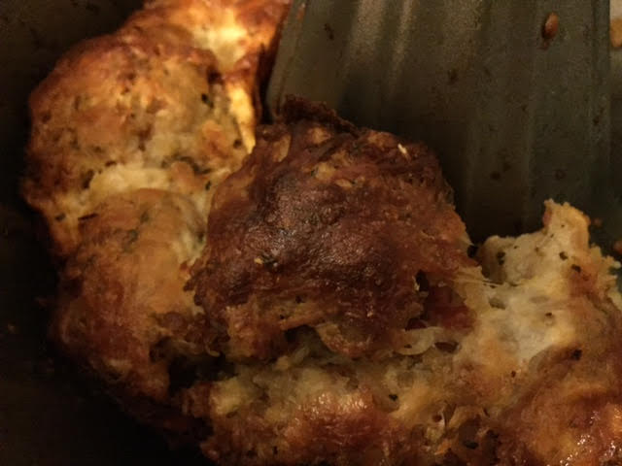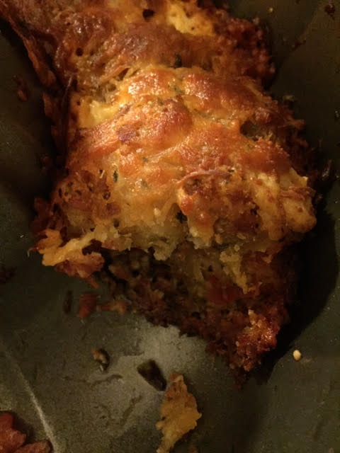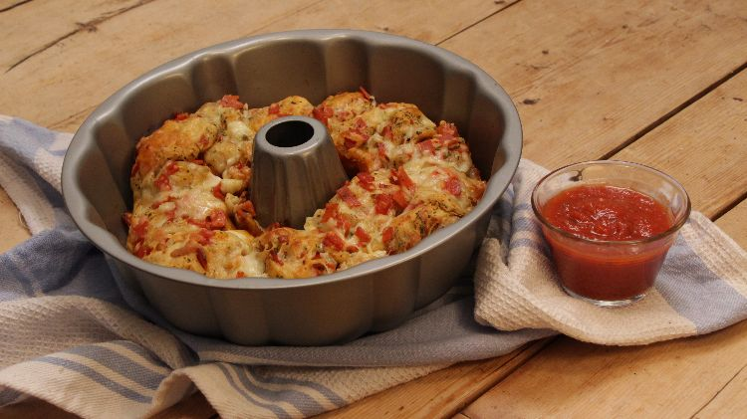

Ingredients:
1 tube of regular pizza crust or biscuits
1½ cups of mozzarella cheese, grated or shredded
½ cup of provolone cheese, grated or shredded
1 cup of pepperoni slices, cut into small pieces
½ cup Parmesan cheese, grated
1 tablespoon of garlic, minced
½ cup olive oil
1½ teaspoons dried oregano
1½ teaspoons dried basil
1½ teaspoons dried parsley
½ teaspoon crushed red pepper
½ teaspoon salt
1 jar marinara sauce, warmed, for dipping

Preparation:
Preheat oven to 350˚ F. Lightly grease a Bundt pan.

In a large bowl, add in pepperoni, ½ cup mozzarella, parmesan, garlic, oregano, basil, parsley, crushed red pepper and salt then mix well. With your hands, gently fold the pepperoni mixture into the dough, making sure not to overwork it - just fold over itself enough times to fully incorporate everything into the dough.

Dip your fingers into the ½ cup olive oil; spreading on the palm of your hands, use your fingers to pinch enough dough to make 1½” rounds (I wear latex gloves to do this). Roll dough between the palms of your hands using enough oil so that the pieces of dough do not stick to each other when touching (don't be afraid to be generous with oil). This step is crucial to making the pull-apart actually pull apart.

Place each piece of dough on a plate until you've rolled out all the dough. Pour the remaining olive oil over dough balls to ensure they don't stick to each other when touching.

Sprinkle remaining 1 cup mozzarella over dough and gently toss with your fingers then transfer into your Bundt pan. Top with provolone cheese and bake for 30 minutes, or until the top is crispy and golden brown. Serve with warm marinara sauce on the side for dipping.

