Italian Peperonata (Sweet Bell Peppers with grilled Sausages) for Two.

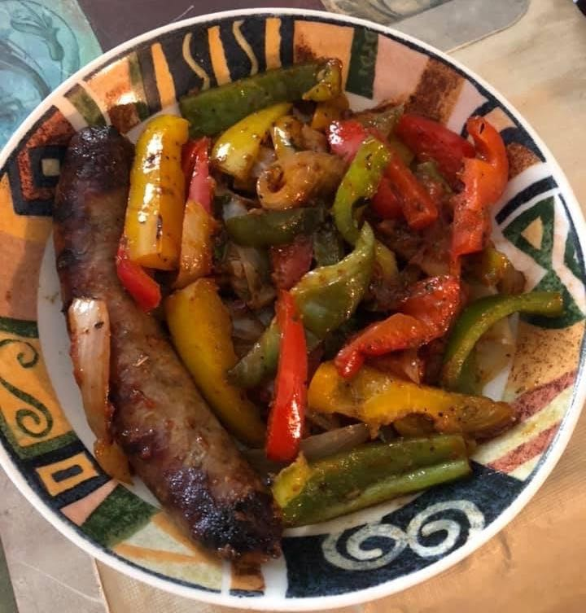

Ingredients:
¼ cup olive oil
2 Italian sausages
3 bell peppers (red, yellow/orange and green), thinly sliced
1 medium onion, halved and thinly sliced
1 medium tomato, halved and thinly sliced
½ cup fresh mushrooms, sliced (optional)
4 cloves garlic, smashed/minced
1 tablespoon tomato paste
1 teaspoon anchovy paste, or 2 – 3 anchovy filets, finely chopped
Salt, freshly ground black pepper and/or crushed-red pepper flakes, to taste
¼ cup dry red wine
½ bunch fresh basil, torn
1 tablespoon dried oregano
1 teaspoon balsamic or red wine vinegar
4 tablespoons water

Preparation:
Heat the olive oil in a large pot over medium heat. Fry the sausages until crisp and brown; remove from pan. Add in the tomato paste and anchovies and fry them for a minute or so, stirring, until the tomato paste turns brick red. Add in onion and garlic; cook, stirring occasionally, until the onion is soft, about 6 minutes.

Add the bell peppers and cook, stirring occasionally, until they begin to soften. You can also add some sliced mushrooms at this point. Add the wine, oregano, crushed-red pepper flakes and water, increase the heat to high and bring to a boil. Reduce the heat to medium low, cover and simmer until the peppers are very soft, about 15 more minutes. I like them to be freshly firm, though.

Uncover, increase the heat to medium and continue cooking, stirring occasionally, until most of the liquid has evaporated, 5 to 10 more minutes. Stir in the basil and vinegar, season with salt and pepper (I season as I go).

Add the sausages back in to the pot with the tomatoes; heat until warmed through.

