Pasta Bianca (Recipe makes 6 – 8 servings)

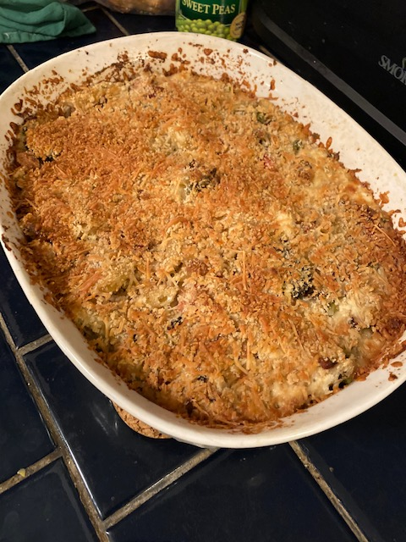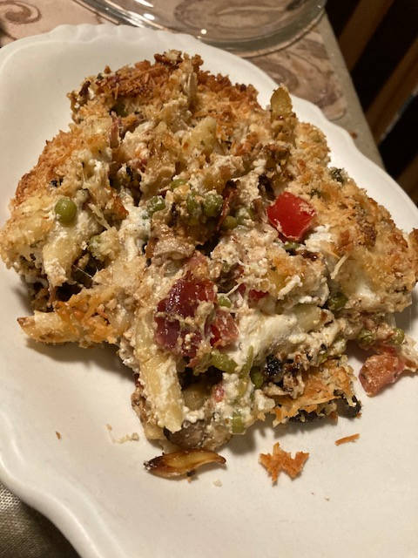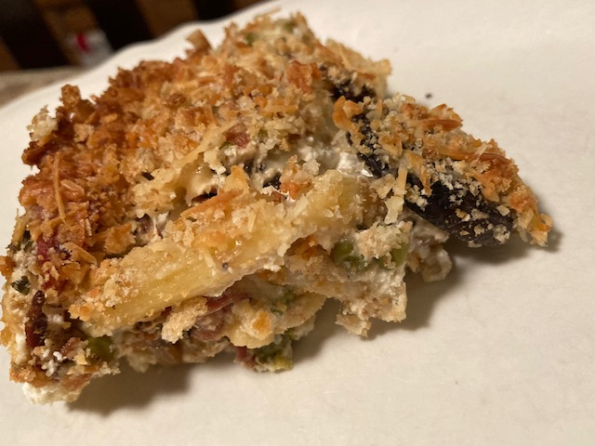

Ingredients:

2 tablespoons butter and/olive oil (plus more for greasing the baking dish)
8 ounces shredded mozzarella
1 ½ cups ricotta
1 teaspoon black pepper
8 ounces penne, pasta shells, rigatoni or whatever kind of short pasta you have on hand
¼ cup bread crumbs
¼ cup grated Parmesan cheese
6 - 8 ounces Italian charcuterie meats, like Calabrese salami, prosciutto and/or capocollo, chopped (I imagine this would also be pretty good using chopped, cooked rotisserie chicken Or canned tuna)
7 - 8 ounces each green peas, diced onion, sliced Cremini mushrooms, diced carrots and diced tomato
4 - 6 cloves garlic, minced
Italian Herbs of choice (I use plenty of oregano, a dash of dried basil, garlic powder and a dash of dried red-pepper flakes)
Salt, to taste

Directions:

Preheat the oven to 375°. Grease a shallow 2-quart baking dish.

Stir together the mozzarella, ricotta, herbs and black pepper in a large bowl. I season this with about half a teaspoon of salt, and I season as I go throughout the recipe.

In a large pot of boiling well-salted water, cook the pasta until al dente. Reserve about 1 cup of the pasta cooking water, and then drain the pasta well.

In a 12” skillet, sauté the meats and vegetables over medium heat in a little olive oil or butter until the onions are caramelized and the meats are browned and crispy. Add them to the bowl of cheese mixture. Mix well.

When the pasta is al dente, thoroughly fold it into the cheese/meat/veggie mixture. Dump it in a shallow, two-quart baking dish greased with butter or olive oil.

In a small bowl, stir together the bread crumbs and Parmesan cheese, then sprinkle the mixture evenly over the pasta.

Bake until the dish is hot throughout and the topping has melted, about 15 minutes. Turn on the broiler and broil the pasta and cheese until the crumbs are golden brown, about 3 minutes. Serve immediately. I bet there’s also freezer is pretty well!

