Virtually No-Carb Cauliflower Pizza Crust (makes enough for a 2-serving pizza)

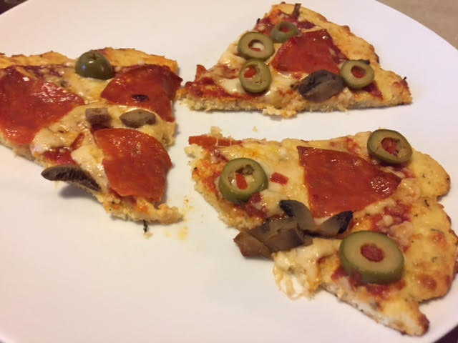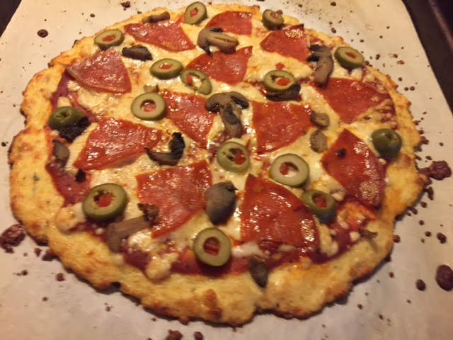

This recipe is amazing! If you’re doing the paleo thing, all the little bits of cauliflower that end up covering your entire kitchen floor while making it is well worth it.

Ingredients:
1 medium head cauliflower, cut into florets
¼ cup grated Parmesan cheese
Italian herbs and seasonings of choice, to taste
¼ teaspoon salt
1 large egg
2 cups freshly grated mozzarella
¼ - ⅓ cup pizza sauce – not too much (see my fabulous recipe)

Preparation:
Preheat the oven to 425° F. Line a baking sheet with parchment paper.

Pulse the cauliflower florets in a food processor to a fine snowy powder (you should have about 2½ cups). Transfer the processed cauliflower to a microwave-safe bowl, cover with plastic wrap and poke a few holes in it to vent. Microwave until soft, 5 minutes. Transfer to a clean, dry kitchen towel and allow to cool.

When cool enough to handle, wrap the cauliflower in the towel and wring out as much moisture as possible, transferring to a second towel if necessary. In a large bowl, stir together the cauliflower, Parmesan, Italian herbs/seasonings, salt, egg and 1 cup of the mozzarella until well combined. Transfer to the prepared baking sheet and press into a very thin 10” round. Bake until golden, 10 to 15 minutes.

Remove the crust from the oven and top with the pizza sauce and remaining 1 cup mozzarella and whatever other garnishes you like (i.e., pepperoni slices, sliced mushrooms, red onion, etc.). Bake until the cheese is melted and bubbly, 10 minutes.

