Neapolitan Ragu (recipe makes 6 – 8 servings)

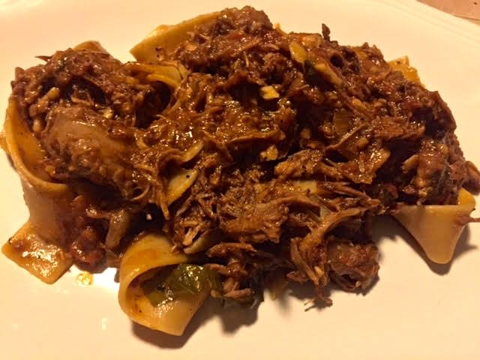

Neapolitan ragu is incredibly rich, meaty and saucy – it’s like no other Italian sauce. This recipe calls for a little Asian fish sauce. But that’s not weird for an Italian dish because the ancient Romans often used their version of fish sauce in their recipes. In Naples, they either serve this ragu cooked together with pasta (as explained below) or simply as a dip for bruschetta. When serving with pasta, prepare a broad pasta for it, like pappardelle.

Ingredients:
1½ pounds pork spare ribs, cut into three chunks
1 pound beef chuck, cut into 2” strips
¼ cup olive oil, divided
½ a large or a small onion, finely chopped (about 1½ cups)
4 medium cloves garlic, finely minced, divided
½ teaspoon dried red chili flakes
1 teaspoon dried oregano
1 cup dry red wine
1 28-ounce can whole peeled San Marzano tomatoes, crushed by hand
1 1” – 2” Parmesan rind (optional)
2 – 3 ounces fresh basil
½ pound mild Italian sausage, in the casings
1½ teaspoons Asian fish sauce

Preparation:
Adjust oven rack to lower-middle position and preheat oven to 300° F. Season ribs with salt and pepper. Heat 2 tablespoons olive oil in a large Dutch oven over high heat until shimmering. Add ribs and cook without moving until well browned. Flip and cook until second side is well browned. Transfer to a plate and set aside. Repeat with beef until browned all over and add to plate with pork.

Add onions to empty Dutch oven and cook, scraping up any browned bits, and stirring frequently until just beginning to brown. Add garlic and continue cooking until onions and garlic are lightly browned, about 3 minutes longer. Add pepper flakes and oregano and cook, stirring, for 30 seconds. Add wine and cook until nearly completely reduced, about 5 minutes. Add tomatoes, Parmesan rind and ¾ of basil. Return ribs and beef to the pot and bring to a simmer.

Cover with lid slightly ajar and place in the preheated oven. Cook, stirring occasionally, until the rib bones can be easily pulled from the meat, about 3 hours. Add sausages and continue cooking for 30 minutes.

Transfer ribs, beef, and sausages to a bowl, discard bones, and let stand until cool enough to handle. Discard basil sprigs from sauce. Roughly shred rib and beef with two forks or your hands and return to pot. Slice sausages into disks and return to sauce. Tear up the remaining basil and stir it into the sauce, along with the fish sauce and remaining olive oil. Check the seasoning, adding more salt and pepper, if necessary.

To serve, cook 2 ounces of pasta per person in a pot of boiling salted water until just shy of al dente (about 1 minute for fresh pasta or 1 minute short of recommended cooking time for dried pasta). Drain, reserving about 1 cup of starchy pasta water. Return pasta to the pot you just cooked it in and add half of ragu, half of pasta cooking water, and a handful of grated cheese. Cook over high heat, stirring until the sauce emulsifies with the pasta water and clings to the pasta, adding more pasta water if necessary. Serve immediately, passing additional sauce and cheese at the table.

