Jeff’s Luscious Marinara Sauce

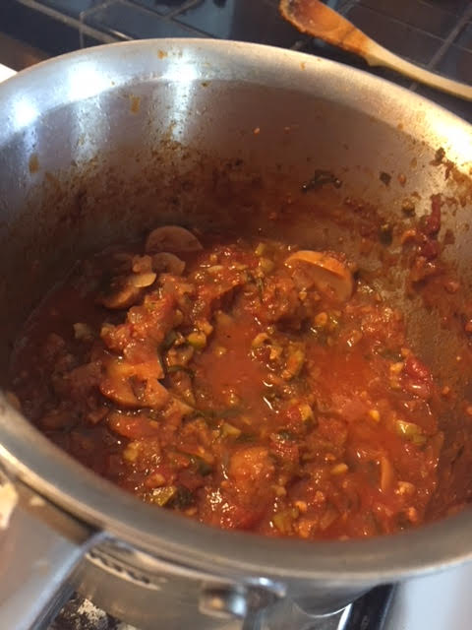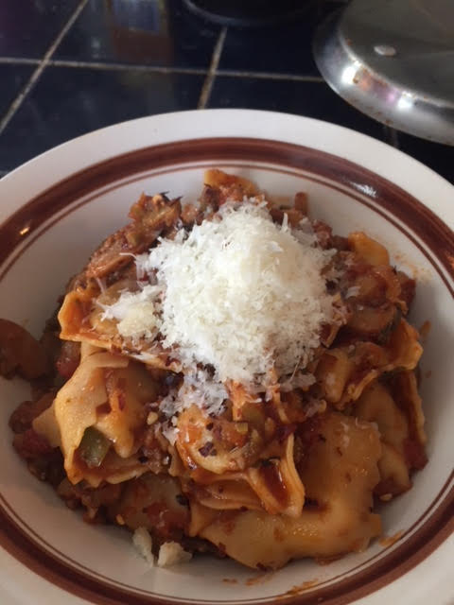

Ingredients:
One 15-ounce can San Marzano tomatoes, crushed by hand with the juice
3 tablespoons lemon juice
A few cloves finally minced fresh garlic
A few leaves fresh basil, julienned
1 tablespoon dried oregano
A handful of pimento – stuffed Spanish olives, chopped
1 teaspoon red-wine vinegar
1 teaspoon salt
½ teaspoon crushed red pepper flakes
1” long Parmesan cheese rind
1 - 2 anchovy fillets
½ a small onion, or a large shallot, finally minced
¼ cup dry red wine (can also use a dry white wine, or vermouth)
3 teaspoons fish sauce (an ancient Roman staple for millennia - found these days at Italian and Asian food markets)
Fresh, chopped parsley, to taste
¼ cup vegetable or chicken stock/bouillon
2 - 3 tablespoons olive oil
1 bay leaf
Sliced mushrooms, to taste (optional – makes it hearty and chunky)

Preparation:
Fry the onion, red pepper flakes and anchovies in the olive oil over medium heat in a saucepan until the onions are translucent and the anchovies are disintegrated. Add all the other ingredients and simmer/reduce for at least one hour in the pot, partially covered.

Remove the cheese rind and bay leaf before serving over pasta or polenta.

