Homemade Gnocchi - recipe makes 4 servings (about 9 gnocchi per serving)

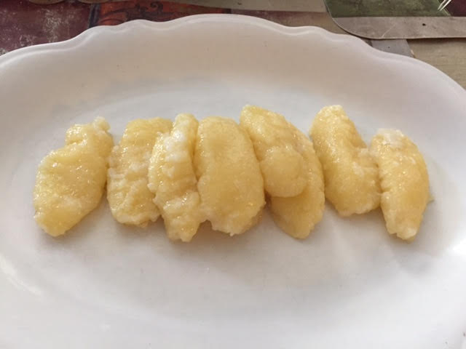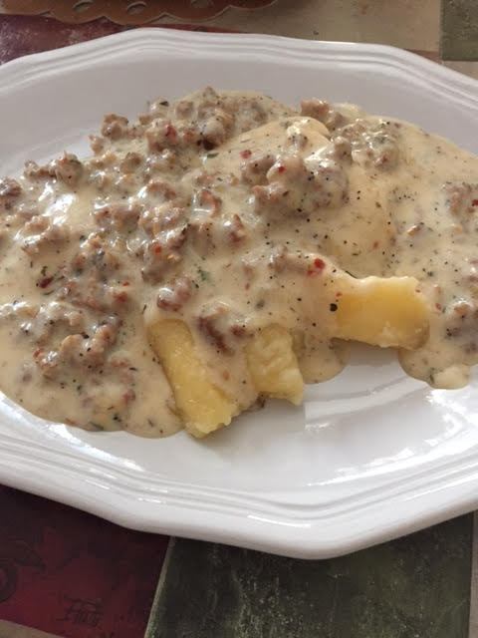

Not made with potatoes, this is a recipe for pillow-soft gnocchi by Giada de Laurentiis which originally called for mixing the zest of two lemons into the batter (I leave it out so I have a more neutral flavor that can accommodate any type of sauce). I use tapioca flour instead of the regular flour – that makes them low-to-no carbs.

Ingredients:
1 cup (8 ounces) mascarpone, at room temperature
- 1 large egg, at room temperature
- 1 large egg yolk, at room temperature
- ¼ teaspoon ground nutmeg
- 1 cup grated Parmesan (4 ounces in weight)
- ½ teaspoon regular table salt
- ¾ cup all-purpose flour, plus extra for forming the gnocchi

Preparation:
In a large bowl, combine the mascarpone, egg, egg yolk, nutmeg, 1 cup grated Parmesan, and salt. Using a hand mixer, beat on medium speed until light and fluffy. Gradually beat in ¾ cup flour until the mixture forms a soft dough.

Sprinkle a pie pan or rimmed baking sheet with more flour. Using 2 small spoons, drop 1 teaspoon-sized pieces of dough into the pie pan. Shake the pan gently to cover the dough with flour. Gently roll the pieces of dough into oval shapes. I also like to form traditional ridges on each of them using two forks. Refrigerate them if making ahead of cooking them.

Bring a large saucepan of salted water to a simmer. In batches, carefully add the gnocchi. The gnocchi should sink and then float to the top. As soon as the gnocchi begin to float, cook for only an additional 1 to 2 minutes. I then scoop them into a colander, let them drain and spread them out on a sheet of parchment paper to cool.

