Spicy Italian-American “Drip Beef” for Two

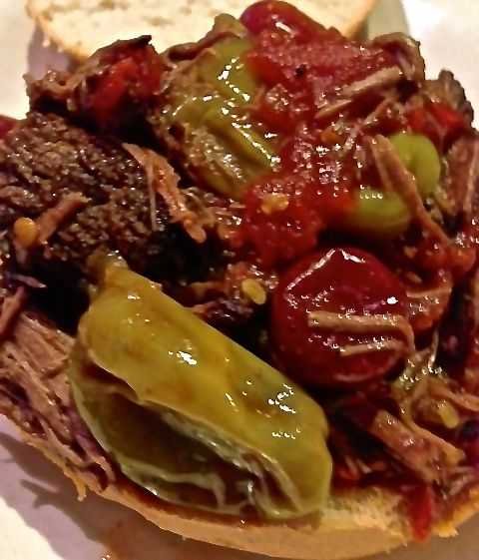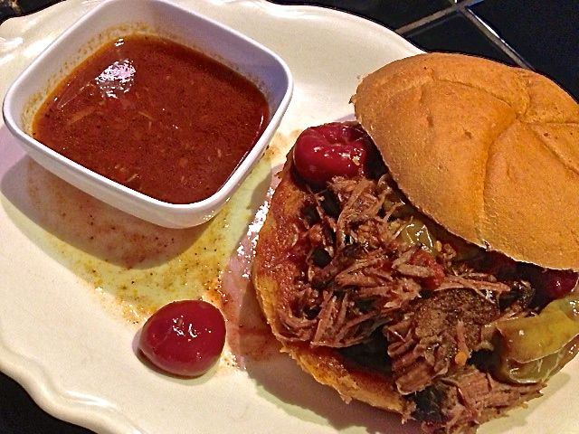

Ingredients:
1½ teaspoons olive oil
¾ pound (12 ounces) Chuck Roast
Salt, ground, black pepper and granulated garlic powder, to taste
1 cup beef broth or bouillon
14 ounces canned, whole tomatoes, crushed by hand
4 ounces whole, hot yellow peppers (“pepperoncini” - about 12 of them), with ½ cup of their juice, stems removed
4 ounces whole cherry peppers (about 6 fat ones), drained and stems removed
1 – 2 ounces jarred pimentos, finely chopped (I buy one of the little 2-ounce jars)
Crushed red-pepper flakes, to taste
Bread rolls for serving (optional)

Preparation:
Preheat oven to 300° F.

Heat the olive oil in a large saucepan over high heat. Season the chuck roast well on both sides with salt, pepper and garlic powder; sear it until well browned on both sides, about 1½ minutes per side. Remove roast from pot and set aside on a plate.

Reduce heat to medium. Pour in beef broth, whisking to scrape the bottom of the pot. Pour in crushed tomatoes, yellow peppers and their juice, the cherry peppers, pimentos and red-pepper flakes. Stir to combine, then add the roast back to the pot.

Place the lid on the saucepan and place it in the oven. Cook for 4 hours, or until meat is fork tender. If it's not, return the pot to the oven for another 30 to 45 minutes, or until it's falling apart. Or cook it in a small (2-quart) slow-cooker on high heat 12 hours (you can prepare it the night before and start it before going to bed on low heat for next day’s supper).

Skim off any fat from the top. Remove the roast to a cutting board and use two forks to shred it up, then return the meat to the cooking liquid. Serve in bread rolls or just piled on a plate with extra juice in dipping cups on the side.

