Herbed White Bean & Sausage Stew (recipe makes 4 servings)

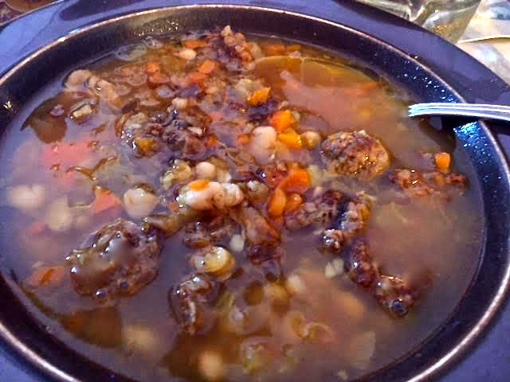

This zuppa di fagioli bianchi e salsiccia alle herbe is easy to make and quite filling!

Ingredients:
½ pound bulk Italian sausage or 2 Italian sausage links, casings removed
2 15-ounce cans cannellini beans or Great Northern white beans, drained and rinsed
4 cups chicken or vegetable stock, or just plain water
1 medium carrot, finely diced
1 rib celery, finely diced
½ onion, chopped
2 garlic cloves, finely chopped
1½ teaspoons tomato paste
¼ teaspoon ground cumin
1 teaspoon salt, or to taste
¼ teaspoon dried thyme
½ teaspoon dried rosemary
1 bay leaf
1 teaspoon balsamic vinegar, more for serving
1 tablespoon olive oil
½ teaspoon ground black pepper, more to taste
Parmesan cheese rinds, scraped clean (optional)
Grated Parmesan, more olive oil and crushed red-pepper flakes, to garnish the soup

Preparation:
Heat a tablespoon of oil in a large pot or Dutch oven over medium-high heat. Add the sausage and sauté until crumbled coarsely and browned to a crisp.

Add the tomato paste and cumin to the pot. Cook, stirring, until dark golden, about 2 minutes. Add the carrots, celery, onion and garlic. Cook, stirring, until the vegetables have softened, about 5 minutes. Stir in the beans, 4 cups stock or water, salt, thyme, rosemary, bay leaf and Parmesan rinds. Turn the heat up to high and bring to a boil. Reduce heat to low, cover the pot and simmer gently, about ½ hour, adding more water or stock if needed to make sure the beans remain submerged.

Stir in the vinegar and pepper. Taste and adjust seasoning. Ladle into warm bowls and serve drizzled with additional vinegar, olive oil grated cheese and pepper flakes.

