Chicken–Stuffed Jumbo Pasta Shells Casserole for Two

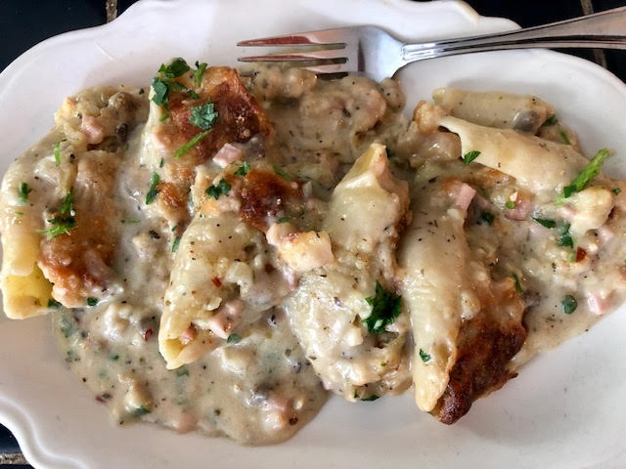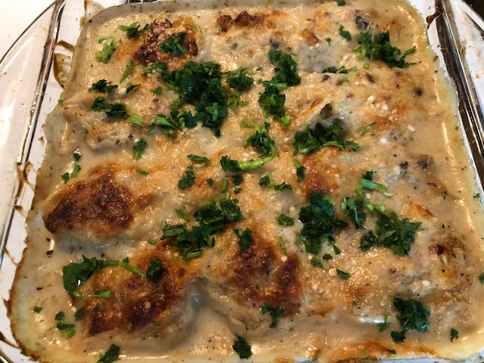

This is a nice alternative to all the tomato-based Italian pasta recipes! It’s a mongrel Italian-American recipe that really hits the spot on a Sunday afternoon.

Ingredients:
½ cup cooked chicken, cut into fairly small pieces
½ cup ham (or soppressata, salami, pepperoni), also cut into small pieces
12 jumbo pasta shells
½ a box of commercial bread-cubes stuffing/dressing (like chicken StoveTop brand)
¼ - ½ cup mayonnaise
4 ounces shredded mozzarella or other Italian cheese
¼ cup chopped onion
1 – 2 cloves fresh garlic, minced
1 10½-ounce can condensed cream of mushroom soup
½ cup milk
¼ cup lemon juice (the juice of 2 lemons)
Dried Italian herbs and spices (like oregano, basil and red-chili-flakes), to taste
Chopped, Italian flat-leaf parsley, to garnish to taste (about 2 tablespoons worth)
¼ - ½ cup grated Parmesan cheese
Salt and pepper, to taste.

Preparation:
Preheat oven to 350 F.° Whisk the cream of mushroom soup with the milk and lemon juice. Season with a little salt, pepper and a hint of dried Italian herbs and spices; set aside.

Cook the jumbo shells just until they are very al dente (still quite firm). Prepare the stuffing/dressing according to package directions. Mix together the stuffing/dressing, the chicken, cheese, onion, garlic, some more Italian herbs/spices and add just enough mayonnaise to hold it together. Season with a little salt and pepper; mix well. Over-stuff the shells with the mixture. You should have enough to stuff all of them. However, if you find that you have more than you can stuff them with, just mix whatever you have remaining into the mushroom sauce.

Spread a thin layer of the mushroom sauce over the bottom of a 9“ x 9“ baking dish. Place the stuffed shells in the baking dish. Pour the remaining sauce over the shells. Sprinkle the grated Parmesan cheese over the top.
Bake for 50 minutes to 1 hour, until golden brown. Garnish the dish with the chopped parsley afterwards and serve with a simple side salad.

