Bell-Pepper Pizzas for Two

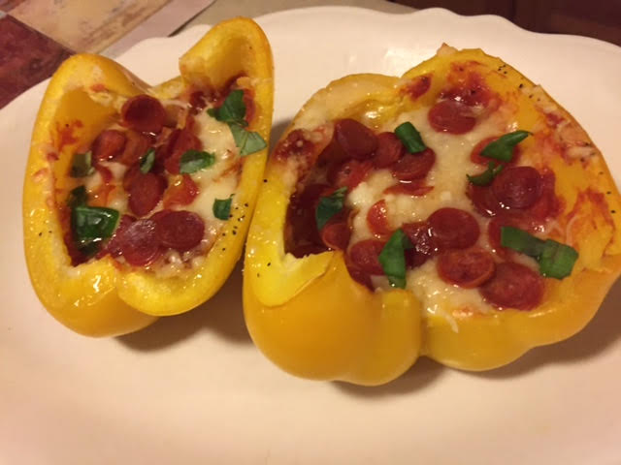

Ingredients:
2 large, yellow bell peppers, halved and cored
1 tablespoon olive oil
Salt and ground black pepper
⅔ cup pizza sauce (see my fabulous recipe for pizza sauce)
1 cup shredded mozzarella
¼ cup finely grated Parmesan
½ cup mini pepperonis, or to taste (I don’t play when it comes to the pepperoni!)
Chopped fresh parsley and/or torn fresh basil leaves, to garnish (optional)

Preparation:
- Preheat oven to 350° F. On a parchment-lined baking sheet, drizzle peppers with olive oil and season with salt and pepper (I also sprinkle on a little garlic powder).

Spoon sauce onto each pepper half. Sprinkle with mozzarella and Parmesan and top with pepperoni. Bake for 15 minutes, or until the peppers are crisp-tender and the cheese is melted.

Garnish with a little finely chopped fresh parsley or torn fresh basil leaves.

