Zesty Guacamole (recipe makes about 4 cups)

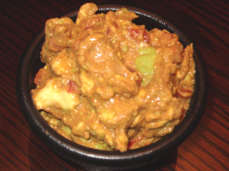

This is my own, zesty recipe for this classic dip. Avocados are loaded with the good kind of fat that lowers bad cholesterol, so don't feel the least bit guilty about indulging in this wonderfully-healthy recipe.

Ingredients:
4 medium-to-large, ripe avocados
1 medium or two small tomatoes (use a firmer variety, but make sure they're ripe)
4 teaspoons onion powder
4 teaspoons garlic powder
1 teaspoons cayenne powder (optional)
1 tablespoons Mexican (dark, mild) chili powder
2 tablespoons limejuice
2 tablespoons lemon juice
1 teaspoon salt

Preparation:
Finely dice the tomatoes and set them aside. Cut the avocados in half, minding that there is a big, hard pit/stone in the center of each!

Once halved, remove the pit/stone from each by quickly and decisively bringing the blade of a large kitchen knife down into the pit, leaving the blade to stick down into it. Give the knife a twist, and the pit/stone should twist right out (if the avocado's not so ripe, you may have to use a little effort to twist the pit/stone out - see notes below).

Once the avocados are sliced and pitted, peel off the leathery, green skins and discard them (I find that the avocado flesh will usually slip right out of the skin-shells using a large spoon). Take your peeled avocado halves then and place them in a large bowl. Chop the avocados up roughly in the bowl using a large spoon.

Next, add the tomatoes and the other ingredients, mixing and folding them well into the avocado flesh. Chill for at least 30 minutes, and keep refrigerated when not being served.

