“White” Texas Chili (recipe serves 8 – 10, but see side notes to make 2 – 4 servings)

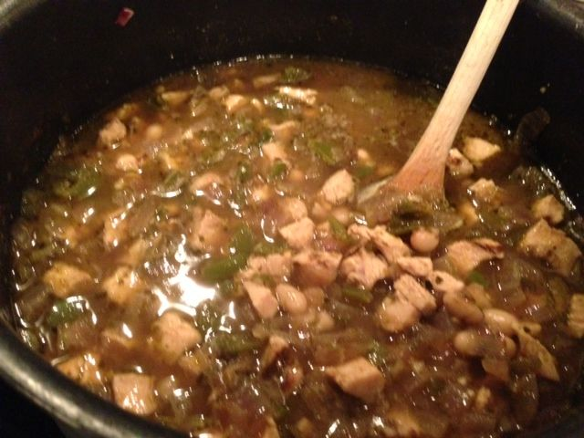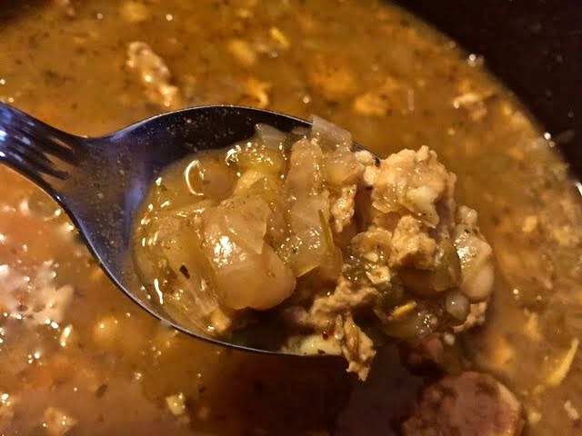

Ingredients:
32 ounces diced, cooked chicken – fried ground chicken breast is really great, too (for 2 servings, use only 8 ounces of chicken)
1 pound white beans, soaked overnight in 3 quarts water, drained (but see note below)
2 – 4 cloves garlic, minced (for 2 servings, use 1 – 2)
2 medium red onions, finely chopped (for 2 servings, use 1)
2, 4-ounce cans chopped, green chilies (for 2 servings, use one can – I like the hot ones!)
1 – 2 fresh jalapeño or Serrano chilies, chopped (optional, but good!)
6 cups low-sodium chicken broth (for 2 servings, use 3 cups)
1 tablespoon olive oil, butter or bacon grease for frying the vegetables and chicken
2 teaspoons ground cumin (for 2 servings, use 1 teaspoon)
1½ teaspoons salt, or to taste (for 2 servings, use ¾ teaspoon)
1½ teaspoons dried oregano - the Mexican kind, if you have it (2 servings = ¾ teaspoon)
½ teaspoon ground, white pepper (for 2 servings, use ¼ teaspoon)
¼ teaspoon ground cloves (for 2 servings, use ⅛ teaspoon)
¼ teaspoon ground red/cayenne pepper (for 2 servings, use ⅛ teaspoon)
Cotija, Chihuahua or other Mexican white or Cheddar cheese, grated for garnish

Preparation:
Sauté the onion, garlic and fresh chilies (if including them) in the fat in a large pot over medium heat until caramelized. Add the canned chilies and seasonings, except the salt – it’ll toughen up the beans if added right away, unless using canned beans (see notes). Add in the chicken and brown to your liking (but it’s not necessary to brown it at all).

Mix well and combine the beans and broth with the onion-chili mixture; bring to a boil. Turn the heat down to a very low setting, just so the contents of the pot just bubble slightly, and simmer, partially covered, for 2½ - 3 hours, or more – until the beans are nice and tender (if using canned beans, an hour will be plenty of time for it to simmer). Add additional water and/or broth, if necessary to keep it fairly thin and flowing.

Serve the chili topped with grated Mexican or Cheddar cheese to taste.

Notes:
You can use three cans of beans, rinsed, instead of soaking dried beans overnight. I like to use a can of black-eyed peas, a can of Great Northerns and a can white/navy beans (for making only enough for two, I just use one can of white/navy beans).

