Tortilla Soup for Two (Sopa de Tortilla para Dos Personas)

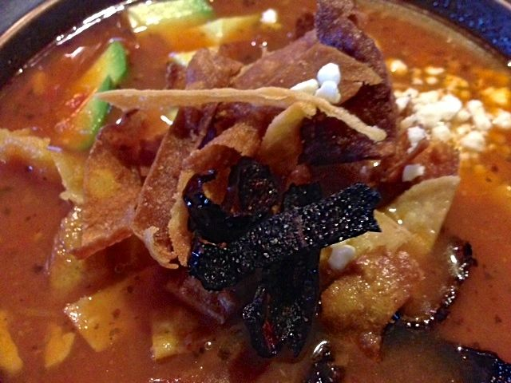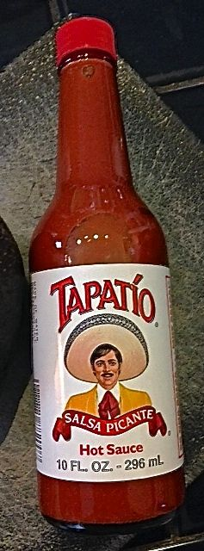

All the ingredients for this traditional, Mexican dish can be found sold at any Latino grocery, like El Rey. The fried ancho-chili strips lend the soup such a deliciously earthy, unique taste experience.

Ingredients:
1 large, flat dried guajillo chili, stemmed and seeded
2 medium-sized, ripe beefsteak tomatoes, whole and unpeeled
1 big garlic clove, whole but peeled
1 small white onion (about 2 – 3 ounces), peeled and roughly chopped
1 teaspoon salt, or to taste
2 tablespoons vegetable oil
2 cups chicken broth
8 corn tortillas, cut into strips 1” – 2” long and about ¼“ wide
Vegetable oil, for frying
1 medium-sized dried ancho or pasilla chili, stemmed, seeded, andcut into 1” strips (optional garnish)
3 – 4 ounces queso fresco, diced or crumbled (optional garnish)
5 – 6 ounces Mexican-style cream, crème fraîche or sour cream (optional garnish)
1 ripe avocado, pitted, flesh scooped out and diced (optional garnish)
½ teaspoon dried parsley flakes
½ teaspoon Mexican oregano
If you want to add some shredded, cooked chicken meat, go ahead!

Preparation:
Set a large, dry saucepan over medium heat. Once it is hot, toast the guajillo chili for about a minute per side, or until you see a little smoking and black spots develop. Set it aside.

Prepare the garnishes next using the same saucepan. I use a pair of kitchen sheers to cut the tortillas in half, then I put them together in manageable stacks and use the sheers to cut them into narrow strips. I use the sheers on the ancho, too. Fill the saucepan with a couple of inches of vegetable oil and bring it to 350° F. on a candy thermometer over medium-high heat. Fry the tortilla strips in very small batches until crispy and golden – I like to have some very dark brown, even burned, too, because they taste awesome. Flash fry the ancho or pasilla chili strips, literally 5 seconds, in the hot oil; season each batch of tortilla/chili strips as you take them out of the oil with a sprinkling of salt and drain on a paper towels while you prepare the rest of the recipe.

Drain the oil from the saucepan and wipe it out thoroughly. Place in it the toasted guajillo, whole tomatoes, and whole garlic clove, season with the salt and cover with water. Place over medium-high heat and bring to a boil. Reduce heat to medium and simmer anywhere from 12 to 15 minutes, until the tomatoes are fully cooked and mushy, and the guajillo has rehydrated and plumped up.

Place the guajillo, tomatoes, garlic and onion in a large food processor, along with 1 cup of the simmering liquid. Puree until completely smooth.

Drain the saucepan, wipe it out again and heat the 2 tablespoons of oil over medium-high heat. Once hot, but not smoking, pour in the tomato puree. It will sizzle and smoke. Partially cover with a lid and let the puree simmer slightly and thicken, changing from a bright red to a darker red and thicker consistency, for about 12 minutes, stirring occasionally. Pour in the chicken broth, parsley flakes, oregano and shredded chicken meat (if adding in any) and, once it comes to a simmer, continue simmering, covered, for another 30 minutes.

Serve in wide soup bowls with a nice bottle of Mexican hot sauce to sprinkle over the soup. Add a huge handful of your fried tortilla crisps, and let your #2 decide how much cream, queso fresco, chili crisps and avocado to add to his or her bowl. Or, if you don’t want to give your #2 a choice, place all the garnishes in the soup plates, and pour the hot soup into the bowls at the table.

