Toro con Tomate (Spanish Beef-Tomato Stew Recipe) Serves 4*

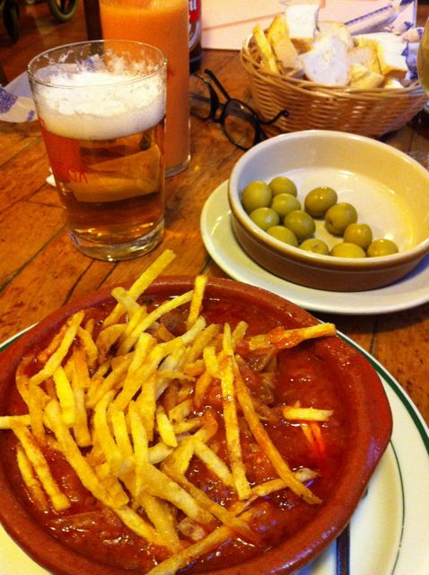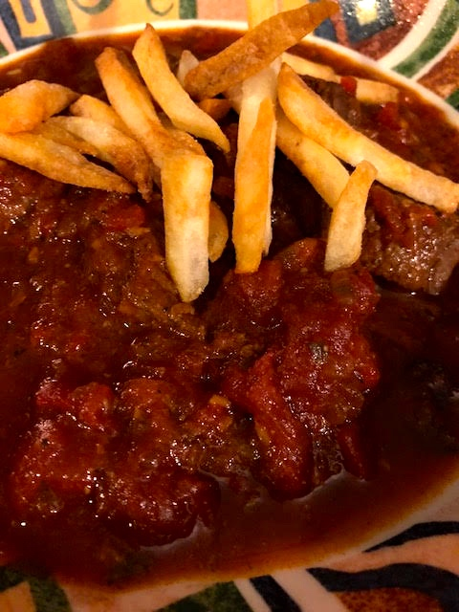

The first photo is one of this dish that I took in Córdoba, Spain. It was made with bull’s meat and was delicious! I found the recipe on line. They say it tastes better the next day and that it's a great way to use leftover grilled meat. It was served to me topped with crispy-fried “shoe string” potatoes (yum)!

Ingredients:
2 tablespoons olive oil
2 to 2½ pounds quality beef, cut into chunks – I like using rump roast
2 large garlic cloves, smashed/pulverized
2 yellow onions, peeled and finely chopped (minced)
1 can (28 ounces) stewed or crushed tomatoes, or 5 - 6 large, ripe tomatoes
½ cup white wine or ¼ cup brandy
2 roasted red bell peppers, skinned, seeded and finely chopped
2 teaspoons parsley
2 teaspoons sweet, Spanish paprika (I like to use the hot/spicy kind of Spanish paprika)
1½ teaspoons salt, 1 teaspoon ground, black pepper – I just season as I go

Preparation:
In a large pot, heat the olive oil over medium-high heat. When it’s smokin’ hot, add the beef and stir to brown on all sides (I first season the meat with a sprinkling of salt, black pepper and garlic powder). Add the chopped onions and sauté on medium to low heat until nicely browned. Add the crushed tomatoes and let cook for a few minutes (I crush tinned, whole imported San Marzano tomatoes by hand into the pot).

While the beef and tomatoes are cooking, peel the garlic and smash it, preferably with a pestal in a mortar, with the parsley. Add a bit of the white wine and swish to clean any garlic and parsley that may be stuck to the inside. Pour garlic-parsley mixture and rest of white wine, the salt, pepper and paprika into the pot. Stir in the roasted bell pepper well, then cover and simmer over very low heat for about 3 hours, until the meat is tender and falling apart. (I pour the contents of the saucepan into a small, removable slow-cooker crockery, cover it and store it in the fridge the night before I want to make this for us. Then I cook it the next day on the low setting for about 8 hours.)

* For two servings, I cut all the ingredients in half (except the paprika).

