Tomatillo Salsa Verde

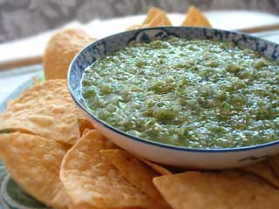

INGREDIENTS:

- 1 1/2 pounds fresh tomatillos or 3 (11-ounce) cans tomatillos
- 5 fresh serrano chiles
- 3 garlic cloves, unpeeled
- 1/2 cup fresh cilantro
- 1 large onion, coarsely chopped
- 2 teaspoons coarse salt

PREPARATION:

Preheat broiler.
If using fresh tomatillos, remove husks and rinse under warm water to remove stickiness. If using canned tomatillos, drain and measure out 2 cups. Broil chiles, garlic, and fresh tomatillos (do not broil canned) on rack of a broiler pan 1 to 2 inches from heat, turning once, until tomatillos are softened and slightly charred, about 7 minutes.
Peel garlic and pull off tops of chiles. Purée all ingredients in a food processor. Transfer to a saucepan and gently simmer over medium heat, until salsa thickens and loses the watery quality.
• Salsa can be made 1 day ahead and chilled, covered.

