Tira de Asado – Argentinean Grilled Beef Short Ribs for Two

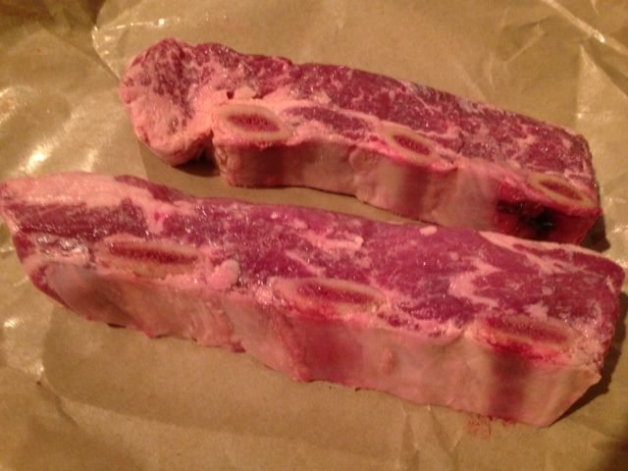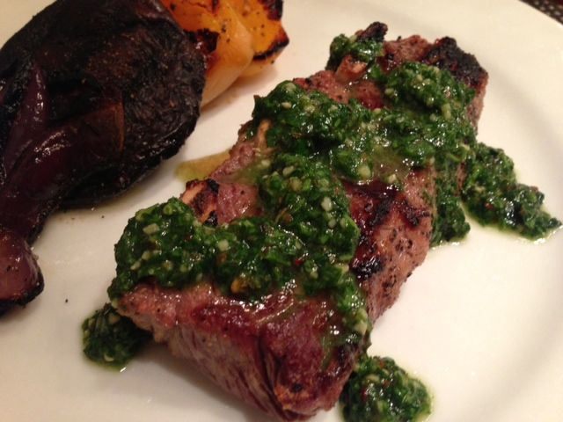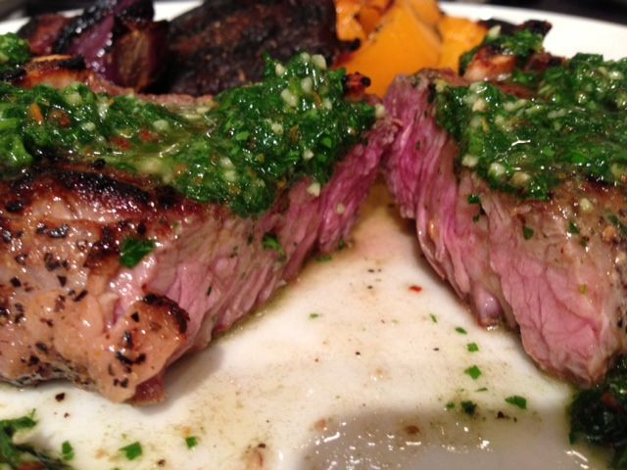

Tira de Asado is Argentinean grilled beef short ribs. Instead of braising short ribs in liquid for a long period of time, the Argentineans slice them thinly across the grain, which tenderizes this typically-tough cut of beef, and they grill them just a few minutes so as to keep them fairly rare and, therefore, very tender. Whole Foods cuts their beef short ribs just how you need them for this recipe!

Ingredients:
2, 1½“-thick slices of bone-in beef short ribs (I per serving about ½ pound each), cut across the ribs such that the bone segments form three “eyes” of rib bone in them
Salt, freshly-ground black pepper and garlic powder
2 tablespoons red wine vinegar and/or lime juice
Preparation:
Trim any surface fat from the ribs. Rub all surfaces of the meat generously with salt, pepper and garlic powder.

The ribs should be just small enough to be able to be placed inside a quart-sized Ziploc bag – if not, then place them in a covered dish that fits them all in a single layer. Drizzle the vinegar/juice over the ribs and turn them over so they have vinegar on both sides. Let the ribs marinate, turning them occasionally at room temperature for up to 1 hour or in the refrigerator for up to 4 hours. This longer marinating time may make the surface of the ribs turn grayish-white in spots - that is fine and the discoloration will disappear when they are grilled.
Heat a gas grill to medium-high or build a strong charcoal fire.

Grill the ribs, turning them once, until well browned, if not charred in spots, about 6 minutes per side. The ribs should be just a bit more rare than medium - anything less and they will be very chewy.

Let them rest 4 to 5 minutes before serving with chimichuri sauce and grilled vegetables’.

