Tangy Tijuana-Style Avocado Salsa – recipe makes about 1½ cups.

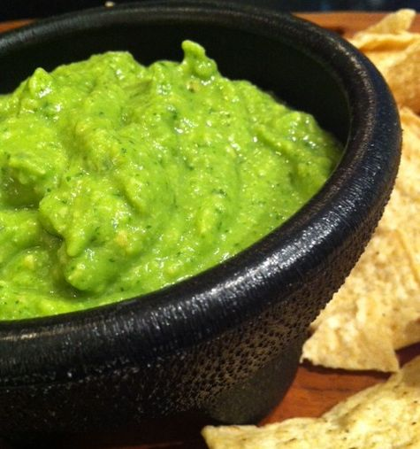

This avocado-based Mexican dressing is not your average guacamole! With the exception of cilantro, all the ingredients are indigenous to the Americas – avocado, chili peppers and peanuts were all discovered by the Spanish in the New World. That makes this recipe about as authentically Aztec as any you’ll ever run across!

Ingredients:

4 tablespoons lime juice (juice of two limes)
1 large, ripe avocado, peeled, pitted and roughly chopped
2 Serrano chilies, stems out and roughly chopped
2 heaping tablespoons shelled, roasted peanuts or green, Mexican pumpkin seeds (it’ll say “pepitas” on the package if you go to buy them at an Hispanic food store)
½ oz. (about 1/3 loosely-packed cup) fresh cilantro
1 teaspoon salt
½ cup water

Preparation:

In a blender or food processor, combine all the ingredients, except the avocado, until completely smooth. Add in the avocado and pulse until thoroughly blended. Check seasoning. Thin it with water if it’s too thick for your liking.

This salsa is used to dress tacos, enchiladas, etc., but it also makes a lovely dip for tortilla chips.

