Texican Cola-Pork Stew – recipe serves 4.

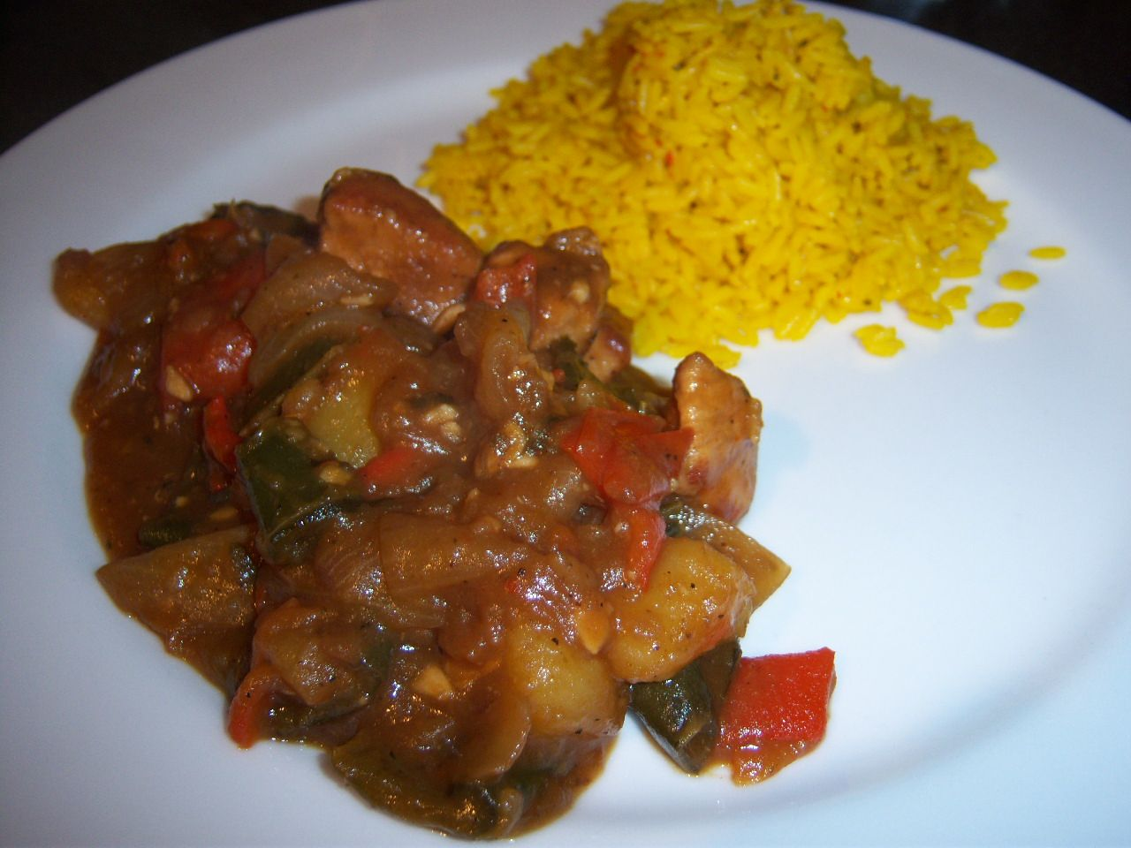

The grandmother of some kid from Texas who grew up to be a famous chef used to make this for him on special occasions, like birthdays and graduations. Food Magazine Executive Editor Sara Moulton featured this recipe on her series. It’s starchy Mexican sweet & sour and IT’S GOOD (I’ve modified it just a tad-bit)!

INGREDIENTS:

1 lb. pork tenderloin, cut into large, 2” – 3” dice
4 TBS. flour seasoned with 1 tsp. each salt, black pepper & garlic powder (to coat the pork)
2 Yukon Gold potatoes, cut into large, 2” – 3” dice
1 Poblano chili, seeded and cut into large chop
1 red bell pepper, seeded and cut into large chop
1 large Spanish onion, peeled and cut into large chop
2 large or 4 medium cloves fresh garlic, minced
2 cups orange juice
2 cups sugary cola, any brand – DO NOT USE DIET!
½ tsp. ground, red (cayenne) pepper
olive oil (to fry in)
more salt & pepper

PREPARATION:

Shake pork cubes in the seasoned flour in a paper bag. In a large saucepan, fry the pork and potatoes together in a little olive oil (no more than 2 TBS.) over medium-high heat until nicely browned (don’t forget to season the potatoes with a little sprinkle of salt & pepper!).

Lower heat to medium-low and add in the onion, season with a little salt & pepper; sauté until softened and lightly caramelized; add in the poblano, bell pepper and garlic (continue to season with salt and pepper as you go). Cook until softened.

Pour in the orange juice, cola and cayenne. Simmer, uncovered, over fairly low heat – but keep it at a nice, active, rolling simmer – an hour, or until thick and delicious. Serve with Mexican rice on the side (I like serving this dish with Goya brand Spanish-style Yellow Rice!).

