Texas-Style Beef Short-Rib Tacos with Habanero Hot Sauce & Avocado-Corn Salsa

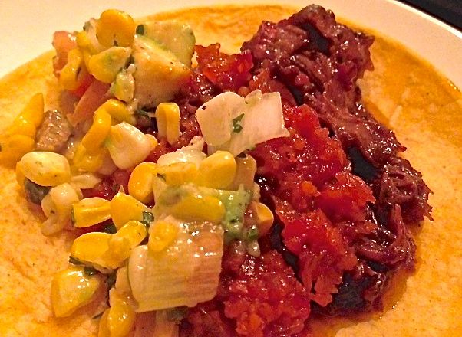 This Tex-Mex recipe serves two.

Ingredients:

For the Ribs
2½ pounds beef short ribs cut into 4” lengths (with the bones, not across them)
Corn tortillas, for making tacos
1 small onion, roughly chopped
2 cloves garlic, roughly chopped
½ of a red bell pepper, roasted, seeded, skinned and roughly chopped (the other half is used in the hot sauce)
1 small red chili, roughly chopped
¼ cup brown sugar
1 tablespoon ground cayenne
1 tablespoon ground ginger
2 tablespoons soy sauce
About ¼ of a bunch fresh cilantro, roughly chopped
¼ cup red wine
3 tablespoons olive oil
¼ cup cider vinegar
¼ cup maple syrup
¼ cup tomato ketchup
¼ cup tomato juice or Italian passata
1 tablespoon Worcestershire sauce
1½ teaspoons salt
1½ teaspoons ground, black pepper

For the Hot Sauce
1½ teaspoons olive oil
1 small (2-ounce) carrot, roughly chopped
1 small (2-ounce) onion, finely chopped
½ of the roasted bell pepper (the other half), chopped
2 - 4 cloves garlic, roughly chopped
3 habanero chilies, roughly chopped
3 tablespoons water
1 small (2 – 4 ounces) tomato, roughly chopped
¼ cup brown sugar
¼ cup cider vinegar
Juice of 1 lime (2 tablespoons)
Salt and ground, black pepper, to taste

For the Avocado-Corn Salsa
1 ear corn, cooked until kernels are tender, kernels cut off
½ avocado, cut into small dice about the same size as corn kernels
1 tomato, seeded and cut into small dice matching the corn and avocado
¼ of a red onion (or a small one about 2 ounces), diced small, too
¼ bunch cilantro, finely chopped
Juice of 1 lime (2 tablespoons)
Olive oil, to taste
Salt and ground, black pepper, to taste

Preparation:
To make the marinade, combine all but the first two ingredients in a food processor and pulse to form a paste.

Arrange the ribs in a shallow baking dish and pour the marinade on, coating them well and evenly all over. Cover with plastic wrap and let marinate in the refrigerator overnight.

Preheat oven to 350° F. Remove the plastic from the ribs’ dish and replace it with a sheet of parchment paper underneath a sheet of aluminum foil (the parchment will keep the foil from corroding from the acids in the sauce). Bake ribs for 3½ hours, until the meat is tender and falling from the bones.

For the hot sauce, heat the oil in a small saucepan over medium heat. Cook the onion with ¼ teaspoon salt until soft.

Place the other half of the roasted red pepper, garlic, tomato, carrot and chilies in a food processor and blend until smooth. Add the mixture to the onions with the sugar, vinegar and limejuice; season to taste. Reduce the heat to low and gently simmer for 30 minutes, until reduced and thickened.

When you’re almost ready to eat, make the salsa by combining the corn kernels, tomato dice, onion dice, avocado dice, cilantro and limejuice in a mixing bowl. Season to taste with salt and pepper.

Warm the tortillas for 30 seconds in the microwave or in a hot skillet. Set out on the table, along with the shredded rib meat mixed well with its baking juices, the hot sauce and the salsa for you and your #2 to make your tacos “family style.”

