Tex-Mex Chicken Taco Rub for Two

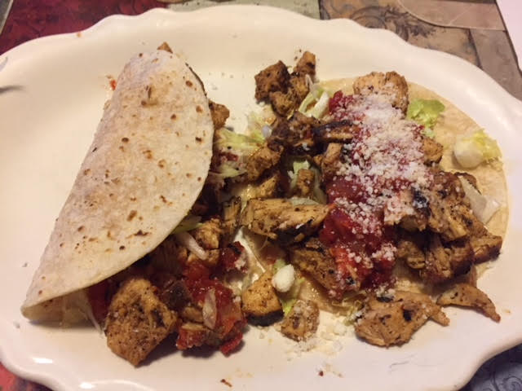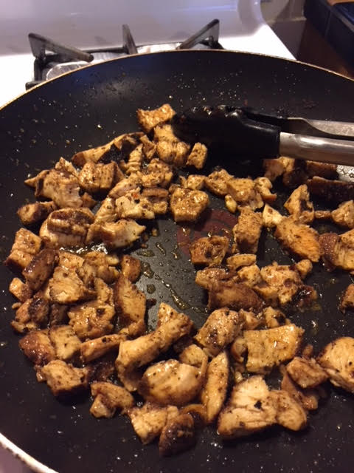

This is a simple, but delicious recipe.

Ingredients:
1 boneless, skinless chicken breast
Corn and/or wheat tortillas
1½ teaspoons ground cumin
1 teaspoon chili powder
½ teaspoon crushed red pepper flakes
½ teaspoon granulated garlic powder
Salt and ground black pepper, to taste
Vegetable oil – enough to shallow fry the chicken
Taco toppings of choice, like shredded lettuce, cheese, chopped tomatoes, avocado slices, Mexican sour cream and salsa

Preparation:
Rub the chicken breast with the spice blend – you only need to let it sit and marinade in its rub just a few minutes, but you can cover them and keep them overnight.

Heat the oil in a pan large enough to accommodate the chicken until hot, but not smoking. Fry the seasoned chicken in the hot oil until nice and brown.

While the chicken fries, warm the tortillas in a dry skillet, or zap them a minute in the microwave. Keep them on a warm platter covered with a clean kitchen towel to them keep nice and warm.

When the chicken is a rich, golden brown, dice it up into small cubes and put them back in the pan, stirring them around to cover them with the pan drippings.

Set out the chicken, warm tortillas and toppings and let everybody make their own! This chicken is also perfect for serving on tostadas (deep fried tortillas).

