Savory “Tamale” Pie (recipe makes 8 servings)

 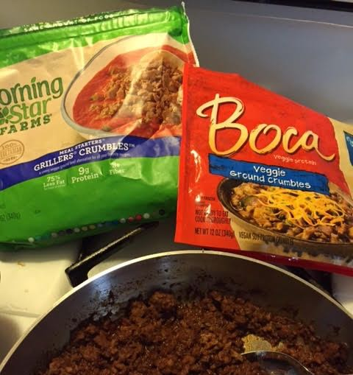 (used for a vegetarian version)

There’s a lot of screwing around with this recipe, but there’s lots leftover to freeze.

Ingredients:
My savory Southern cornbread batter (all the ingredients for the whole recipe):
http://www.seabrite.com/Recipes/American%20&%20Misc./Corn%20Bread.doc
1½ teaspoons peanut or other vegetable oil
1 pound lean ground beef - I make a vegetarian version with faux meat crumbles
½ onion (or a small one), chopped
½ red bell pepper (or a small one), seeded and chopped
1 jalapeño, sliced
1 poblano chili, seeded and chopped
1½ teaspoons chili powder
1 teaspoon ground cumin
Salt and ground, black pepper
2 cloves garlic, chopped
1, 15-ounce can chopped tomatoes – I use a can of hand-crushed San Marzanos
1, 15-ounce can red kidney beans, drained and rinsed
½ cup beef or vegetable bouillon broth
1 tablespoon tomato paste
Butter, for greasing the skillet

Preparation:
Preheat the oven to 425° F. Mix up my cornbread batter and let it sit out uncovered.

In a large skillet over medium-high heat, add the oil. Cook the beef, breaking up any lumps, until it is no longer pink. Add the onion, bell pepper, garlic and chilies to the pan; season with the chili powder, cumin, salt and pepper. Sauté until just brown. Add the canned tomatoes, broth and tomato paste; bring to a boil. Add the beans and return the meat to the skillet. Simmer on medium-low heat for about 20 minutes.

Preheat a 13” x 9” x 2” glass baking dish with butter in the hot oven, as per my cornbread recipe. Carefully line the bottom of the screaming-hot dish with a little over half of the cornbread mixture. Quickly add in the meat filling evenly, then spoon the rest of the cornbread mixture over the top – you may not be able to cover all the meat filling, but that’s all right. Bake until golden brown, 20 to 25 minutes.

