Tacos al Pastor for Two (3 tacos each)

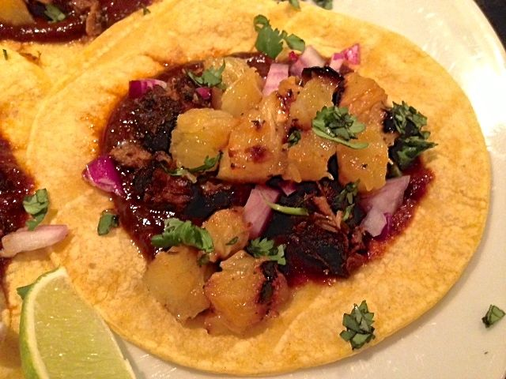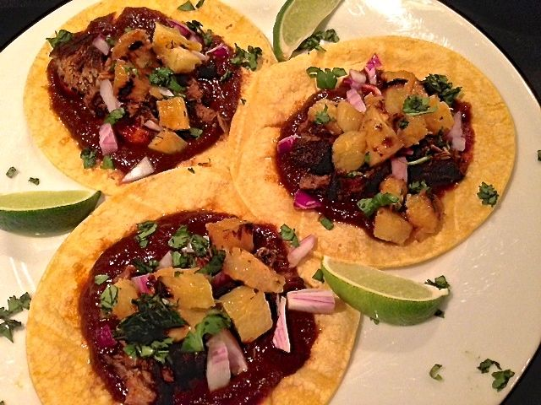

This is the most popular kind of taco served in Mexico City. The meat for these is traditionally prepared in the same way that Greek gyro meat is roasted on a vertical, rotating spit. This is an easy way to make it without the vertical rotisserie.

Ingredients:
½ pound boneless pork butt roast
A quarter of a pineapple, peeled, cored and cut into ½″-thick rings
Vegetable oil, to brush onto the pineapple rings for grilling
1 lime, cut into 8, small slices
4, 6” corn tortillas
1 small onion (about 2 ounces), diced
¼ cup fresh cilantro, chopped

For the Sauce
4 dried guajillo chilies – these are dark, sweet and mild
1 dried ancho chili – these have a spicy kick to them
1 tablespoon achiote paste (sold at Latin groceries, or make your own by finely grinding together 1 tablespoon annatto/achiote seeds, ½ teaspoon cumin seeds or powder, ½ teaspoon peppercorns or chipotle chili, 2 large or 3 small allspice berries or ¼ teaspoon ground allspice, ½ teaspoon salt and ⅛ teaspoon nutmeg; mix this powder with water, 1 teaspoon at a time, until you have a thick paste – freeze remainder by the tablespoon for other use later)
1 chipotle chili in adobo (about a tablespoon), minced – I like La Costeña brand
⅛ teaspoon Mexican oregano
1 cup water
4½ teaspoons cup white vinegar
2 garlic cloves
1 small bay leaf
½ teaspoon salt
⅛ teaspoon ground, black pepper
¼ teaspoon sugar
⅛ teaspoon ground cumin
⅛ teaspoon ground cloves
Preparation:
Wipe the dried chilies clean, then add them into a medium-sized, dry pot set over medium-high heat. Toast them a few minutes until they become soft, pliable and fragrant. Remove them to the side and let cool enough to handle; remove the stems and seeds, tearing them apart as you go. Peel the garlic while you bring the pot back to medium-high heat; add the achiote paste, all the chilies, the oregano, vinegar, water, bay leaf, salt, pepper, sugar, cumin and cloves. Bring to a simmer, cover pot and reduce heat to low. Cook for 20 minutes, stirring occasionally, until the chilies become soft.

While the sauce simmers, trim off any large pieces of fat from the pork roast. Cut the roast against the grain into little pork steaks about ½″ thick.

After the sauce has cooked the 20 minutes, add it to a food processor and pulse on high speed for a minute or so, until smooth. Place a fine-mesh strainer over the pot; strain the puree into it, pressing down to get as much liquid as possible out of it back into the pot.

Arrange the pork steaks in the sauce, mixing in additional water so that they are fully submerged. Bring sauce back up to a simmer over a medium-low heat, just high enough to maintain a gentle simmer with the cover slightly ajar. Let it all simmer 2 hours, flipping and rearranging the steaks every 60 minutes to insure even cooking.

In the last 20 minutes, light about 100 charcoal briquettes in your grill or preheat gas grill to medium. Fish out the pork steaks from the sauce, sprinkle both sides with salt. Squeeze the juice of 2 lime wedges in and place the spent lime wedges into the sauce in the pot. Stir well and keep the sauce simmering gently on low heat.

When the charcoal is covered with a fine grey ash, distribute the coals evenly in the grill. Clean and oil the grate. When using a gas grill, I cover it with aluminum foil, like when grilling Korean bulgogi (it works great!). Grill the pork steaks and pineapple on separate sides of the grill for 6 to 7 minutes on each side, until steaks have browned nicely and pineapple has dark grill marks.

Dice the grilled pineapple rings and shred the pork.

Microwave the tortillas on high for 30 seconds or heat in a small skillet over high heat 30 seconds. Place on each tortilla first an equal amount of the sauce, then of the pork, then a little diced onion, topped with grilled pineapple and garnished with a sprinkling of chopped cilantro. Serve these tacos open (you roll them yourselves at the table). Divide the lime wedges equally between you and your #2 so you can both squeeze lots of fresh, zippy limejuice all over your Tacos al Pastor.

